StudentHub Academic Portal
Responsive UI/UX Engineering Report: CSS Grid, Flexbox, Mobile-First Architecture, Source Code & Visual Outputs
Project Scope | Design responsive layouts for Home, About, Registration, Dashboard, and Events (+ Full Portal)
Layout Engine | CSS Grid (2, 3, 4-column auto-fit grids) and Flexbox (navigation, hero, card bars, headers)
Responsive Strategy | Mobile-First (Base: <768px, Tablet: 768px-1024px, Desktop: >=1024px)
Documentation Scope | Full source code, architectural breakdown, and dual Desktop/Mobile output screenshots

1. Executive Summary & Design System Architecture
StudentHub is a comprehensive college web portal designed to provide students with intuitive, real-time access to academic curricula, assignments, grades, attendance tracking, and campus events. The primary design objective was to re-architect the entire portal using modern CSS Grid and Flexbox with a strict mobile-first paradigm, completely eliminating viewport overflow, raw unstyled layout stretches, and accessibility barriers.
📌 Core Technical Pillars
• Mobile-First Responsive CSS: Base styles target smartphone viewports (<768px), progressively enhanced via media queries for tablets (min-width: 768px) and desktop displays (min-width: 1024px).
• CSS Grid System: Powers multi-column card dashboards, feature showcases, statistical metric cards (auto-fit minmax), and multi-field registration forms.
• Flexbox Engine: Powers sticky header navigation, off-canvas drawer toggles, hero action alignments, badge status chips, and responsive data tables.
• WCAG 2.1 Accessibility: Skip-navigation anchors, semantic landmark tags (<header>, <nav>, <main>, <aside>, <footer>), and 44px minimum touch targets.

2. Core Global Architecture: CSS & Navigation Script

2.1 Master Stylesheet (css/style.css)
The master stylesheet defines design tokens (variables), base typography resets, container utility rules, CSS Grid card layouts, responsive tables, badge systems, and media queries across all breakpoints.
/* ==========================================================================
StudentHub - Modern Responsive CSS Design System
Built Mobile-First using CSS Grid and Flexbox
========================================================================== */

/* --------------------------------------------------------------------------
1. CSS Custom Properties / Design Tokens
-------------------------------------------------------------------------- */
:root {
/* Brand Color Palette */
--color-primary: #2563eb;
--color-primary-dark: #1d4ed8;
--color-primary-light: #eff6ff;
--color-primary-rgb: 37, 99, 235;

--color-secondary: #4f46e5;
--color-secondary-dark: #4338ca;
--color-secondary-light: #eef2ff;

--color-accent: #06b6d4;
--color-accent-light: #ecfeff;

/* Neutral Slate Colors */
--color-bg: #f8fafc;
--color-surface: #ffffff;
--color-surface-hover: #f1f5f9;
--color-text-main: #0f172a;
--color-text-muted: #64748b;
--color-text-light: #94a3b8;
--color-border: #e2e8f0;
--color-border-dark: #cbd5e1;

/* Status Colors */
--color-success: #10b981;
--color-success-bg: #ecfdf5;
--color-warning: #f59e0b;
--color-warning-bg: #fffbeb;
--color-danger: #ef4444;
--color-danger-bg: #fef2f2;
--color-info: #0284c7;
--color-info-bg: #f0f9ff;

/* Typography */
--font-family-base: -apple-system, BlinkMacSystemFont, "Segoe UI", Roboto, "Helvetica Neue", Arial, sans-serif;
--font-family-mono: ui-monospace, SFMono-Regular, Menlo, Monaco, Consolas, monospace;

--font-size-xs: 0.75rem; /* 12px */
--font-size-sm: 0.875rem; /* 14px */
--font-size-base: 1rem; /* 16px */
--font-size-md: 1.125rem; /* 18px */
--font-size-lg: 1.25rem; /* 20px */
--font-size-xl: 1.5rem; /* 24px */
--font-size-2xl: 1.875rem; /* 30px */
--font-size-3xl: 2.25rem; /* 36px */
--font-size-4xl: 2.75rem; /* 44px */

/* Spacing */
--space-1: 0.25rem;
--space-2: 0.5rem;
--space-3: 0.75rem;
--space-4: 1rem;
--space-5: 1.25rem;
--space-6: 1.5rem;
--space-8: 2rem;
--space-10: 2.5rem;
--space-12: 3rem;
--space-16: 4rem;

/* Elevation Shadows */
--shadow-sm: 0 1px 2px 0 rgba(0, 0, 0, 0.05);
--shadow-md: 0 4px 6px -1px rgba(0, 0, 0, 0.08), 0 2px 4px -2px rgba(0, 0, 0, 0.05);
--shadow-lg: 0 10px 15px -3px rgba(0, 0, 0, 0.08), 0 4px 6px -4px rgba(0, 0, 0, 0.05);
--shadow-xl: 0 20px 25px -5px rgba(0, 0, 0, 0.1), 0 8px 10px -6px rgba(0, 0, 0, 0.05);

/* Borders & Radius */
--radius-sm: 0.375rem; /* 6px */
--radius-md: 0.5rem; /* 8px */
--radius-lg: 0.75rem; /* 12px */
--radius-xl: 1rem; /* 16px */
--radius-full: 9999px;

/* Transitions */
--transition-fast: 0.15s ease;
--transition-normal: 0.25s ease;
}

/* --------------------------------------------------------------------------
2. Base Reset & Typography (Mobile-First)
-------------------------------------------------------------------------- */
*, *::before, *::after {
box-sizing: border-box;
margin: 0;
padding: 0;
}

html {
font-size: 16px;
scroll-behavior: smooth;
-webkit-text-size-adjust: 100%;
}

body {
font-family: var(--font-family-base);
font-size: var(--font-size-base);
line-height: 1.6;
color: var(--color-text-main);
background-color: var(--color-bg);
min-height: 100vh;
display: flex;
flex-direction: column;
overflow-x: hidden;
}

img, svg {
max-width: 100%;
display: block;
}

a {
color: var(--color-primary);
text-decoration: none;
transition: color var(--transition-fast);
}

a:hover, a:focus-visible {
color: var(--color-primary-dark);
text-decoration: underline;
}

h1, h2, h3, h4, h5, h6 {
color: var(--color-text-main);
line-height: 1.25;
font-weight: 700;
margin-bottom: var(--space-3);
}

h1 { font-size: var(--font-size-2xl); }
h2 { font-size: var(--font-size-xl); }
h3 { font-size: var(--font-size-lg); }
p { margin-bottom: var(--space-4); color: var(--color-text-muted); }

hr {
border: 0;
border-top: 1px solid var(--color-border);
margin: var(--space-6) 0;
}

table {
width: 100%;
border-collapse: collapse;
margin-bottom: var(--space-6);
font-size: var(--font-size-sm);
background-color: var(--color-surface);
border-radius: var(--radius-md);
overflow: hidden;
}

table th, table td {
padding: var(--space-3) var(--space-4);
border: 1px solid var(--color-border);
text-align: left;
}

table th {
background-color: #f8fafc;
font-weight: 600;
color: var(--color-text-main);
}

ul, ol {
margin-bottom: var(--space-4);
padding-left: var(--space-6);
color: var(--color-text-muted);
}

li {
margin-bottom: var(--space-2);
}

/* Accessible Skip Navigation Link */
... [1192 more lines in actual file]

2.2 Mobile Navigation Toggle Script (js/main.js)
A lightweight, vanilla JavaScript module providing smooth hamburger menu toggling, outside-click dismissal, and keyboard accessibility (Escape key close).
/**
* StudentHub - Main Navigation and Accessibility Script
*/
document.addEventListener('DOMContentLoaded', () => {
const navToggle = document.querySelector('.nav-toggle');
const navMenu = document.querySelector('.nav-menu');

if (navToggle && navMenu) {
navToggle.addEventListener('click', () => {
const isExpanded = navToggle.getAttribute('aria-expanded') === 'true';
navToggle.setAttribute('aria-expanded', !isExpanded);
navMenu.classList.toggle('is-active');
});

// Close mobile nav when clicking outside
document.addEventListener('click', (e) => {
if (!navToggle.contains(e.target) && !navMenu.contains(e.target) && navMenu.classList.contains('is-active')) {
navMenu.classList.remove('is-active');
navToggle.setAttribute('aria-expanded', 'false');
}
});

// Close on Escape key
document.addEventListener('keydown', (e) => {
if (e.key === 'Escape' && navMenu.classList.contains('is-active')) {
navMenu.classList.remove('is-active');
navToggle.setAttribute('aria-expanded', 'false');
navToggle.focus();
}
});
}
});

3. Page-by-Page Code & Output Screenshots

3.1 Home Page (index.html)
Description: The primary landing page introducing StudentHub features, live semester metrics, enrollment CTAs, and university navigation shortcuts.
📌 CSS Grid & Flexbox Techniques
• Flexbox: Split Hero Banner (hero text on left, live portal card on right), sticky brand navigation.
• CSS Grid: 3-column auto-fit Features Grid, 4-column Statistics Metric Counters, and 3-column Quick Navigation Links.

Rendered Output Screenshots (Desktop & Mobile):
💻 Desktop View (1280px) | 📱 Mobile View (412px)
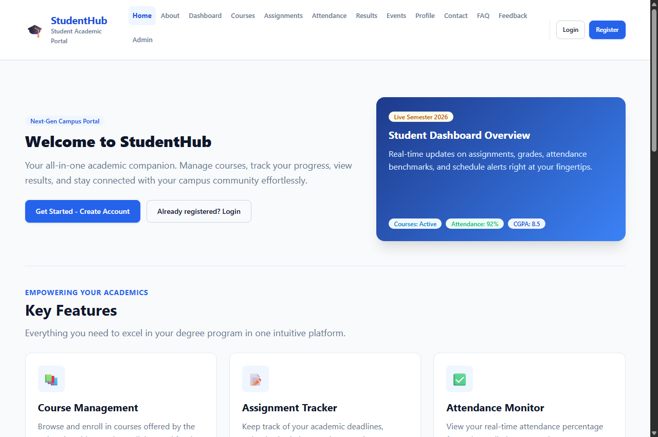 | 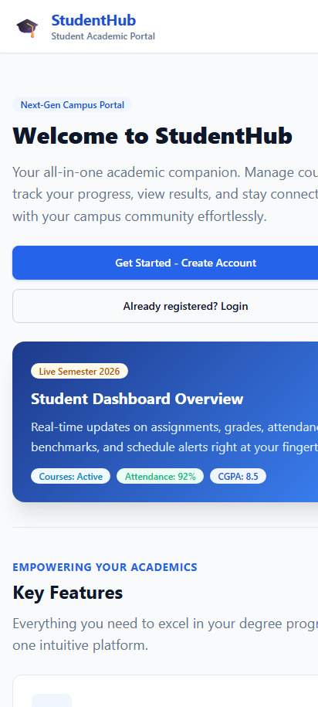

Complete Source Code:
<!DOCTYPE html>
<html lang="en">
<head>
<meta charset="UTF-8">
<meta name="viewport" content="width=device-width, initial-scale=1.0">
<meta name="description" content="StudentHub - Your one-stop student academic portal for managing courses, assignments, attendance, and more.">
<title>StudentHub - Student Academic Portal</title>
<link rel="stylesheet" href="css/style.css">
</head>
<body>

<a href="#main-content" class="skip-link">Skip to main content</a>

<!-- Site Header with Flexbox Navigation -->
<header class="site-header">
<div class="container header-inner">
<a href="index.html" class="brand">
<span class="brand-icon" aria-hidden="true">&#127891;</span>
<div class="brand-text">
<h1>StudentHub</h1>
<p>Student Academic Portal</p>
</div>
</a>

<!-- Mobile Navigation Toggle -->
<button class="nav-toggle" aria-label="Toggle navigation menu" aria-expanded="false">
<span></span>
<span></span>
<span></span>
</button>

<!-- Navigation Links -->
<nav class="nav-menu" aria-label="Main navigation">
<ul class="nav-links">
<li><a href="index.html" class="nav-link active">Home</a></li>
<li><a href="pages/about.html" class="nav-link">About</a></li>
<li><a href="pages/dashboard.html" class="nav-link">Dashboard</a></li>
<li><a href="pages/courses.html" class="nav-link">Courses</a></li>
<li><a href="pages/assignment.html" class="nav-link">Assignments</a></li>
<li><a href="pages/attendance.html" class="nav-link">Attendance</a></li>
<li><a href="pages/result.html" class="nav-link">Results</a></li>
<li><a href="pages/events.html" class="nav-link">Events</a></li>
<li><a href="pages/profile.html" class="nav-link">Profile</a></li>
<li><a href="pages/contact.html" class="nav-link">Contact</a></li>
<li><a href="pages/faq.html" class="nav-link">FAQ</a></li>
<li><a href="pages/feedback.html" class="nav-link">Feedback</a></li>
<li><a href="pages/admin.html" class="nav-link">Admin</a></li>
</ul>
<div class="nav-auth-buttons">
<a href="pages/login.html" class="btn btn-outline btn-sm">Login</a>
<a href="pages/register.html" class="btn btn-primary btn-sm">Register</a>
</div>
</nav>
</div>
</header>

<main id="main-content" class="site-main">
<div class="container">

<!-- Hero Section using Flexbox -->
<section class="hero-section" aria-labelledby="hero-heading">
<div class="hero-content">
<span class="badge badge-primary hero-badge">Next-Gen Campus Portal</span>
<h2 id="hero-heading" class="hero-title">Welcome to StudentHub</h2>
<p class="hero-lead">Your all-in-one academic companion. Manage courses, track your progress, view results, and stay connected with your campus community effortlessly.</p>
<div class="hero-actions">
<a href="pages/register.html" class="btn btn-primary">Get Started - Create Account</a>
<a href="pages/login.html" class="btn btn-outline">Already registered? Login</a>
</div>
</div>
<div class="hero-preview-card">
<div>
<span class="badge badge-warning" style="margin-bottom: 0.75rem;">Live Semester 2026</span>
<h3>Student Dashboard Overview</h3>
<p>Real-time updates on assignments, grades, attendance benchmarks, and schedule alerts right at your fingertips.</p>
</div>
<div style="display: flex; gap: 0.5rem; flex-wrap: wrap;">
<span class="badge badge-info">Courses: Active</span>
<span class="badge badge-success">Attendance: 92%</span>
<span class="badge badge-primary">CGPA: 8.5</span>
</div>
</div>
</section>

<!-- Key Features using CSS Grid -->
<section style="margin-bottom: var(--space-12);" aria-labelledby="features-heading">
<div class="section-title-wrap">
<p class="section-subtitle">Empowering Your Academics</p>
<h2 id="features-heading">Key Features</h2>
<p class="section-desc">Everything you need to excel in your degree program in one intuitive platform.</p>
</div>

<div class="grid-responsive-cards">
<article class="feature-card">
<div class="feature-icon-box" aria-hidden="true">&#128218;</div>
<h3>Course Management</h3>
<p>Browse and enroll in courses offered by the university with complete syllabus and faculty details.</p>
<div class="card-footer">
<a href="pages/courses.html" class="btn btn-sm btn-outline">Browse Courses &rarr;</a>
</div>
</article>

<article class="feature-card">
<div class="feature-icon-box" aria-hidden="true">&#128221;</div>
<h3>Assignment Tracker</h3>
<p>Keep track of your academic deadlines, upload submissions, and never miss an upcoming due date.</p>
<div class="card-footer">
<a href="pages/assignment.html" class="btn btn-sm btn-outline">View Assignments &rarr;</a>
</div>
</article>

<article class="feature-card">
<div class="feature-icon-box" aria-hidden="true">&#9989;</div>
<h3>Attendance Monitor</h3>
<p>View your real-time attendance percentage for each enrolled course and ensure mandatory eligibility.</p>
<div class="card-footer">
<a href="pages/attendance.html" class="btn btn-sm btn-outline">Check Attendance &rarr;</a>
</div>
</article>

<article class="feature-card">
<div class="feature-icon-box" aria-hidden="true">&#127942;</div>
<h3>Results &amp; Grades</h3>
<p>Check semester-wise scorecards, track SGPA and cumulative CGPA trends, and download transcripts.</p>
<div class="card-footer">
<a href="pages/result.html" class="btn btn-sm btn-outline">View Grades &rarr;</a>
</div>
</article>

<article class="feature-card">
<div class="feature-icon-box" aria-hidden="true">&#127881;</div>
<h3>Campus Events</h3>
<p>Discover upcoming tech fests, hackathons, sports tournaments, and professional guest seminars.</p>
<div class="card-footer">
<a href="pages/events.html" class="btn btn-sm btn-outline">Explore Events &rarr;</a>
</div>
</article>

<article class="feature-card">
<div class="feature-icon-box" aria-hidden="true">&#128100;</div>
<h3>Student Profile</h3>
<p>Manage your personal profile, academic documents, contact info, and emergency contact details.</p>
<div class="card-footer">
<a href="pages/profile.html" class="btn btn-sm btn-outline">Edit Profile &rarr;</a>
</div>
</article>
</div>
</section>

<!-- Quick Statistics using CSS Grid -->
<section style="margin-bottom: var(--space-12);" aria-labelledby="stats-heading">
<div class="section-title-wrap">
<p class="section-subtitle">Portal Metrics</p>
<h2 id="stats-heading">Quick Statistics</h2>
<p class="section-desc">Key campus milestones and community figures across our university.</p>
</div>

<div class="grid-stats" style="margin-bottom: var(--space-6);">
<div class="stat-card">
<span class="stat-number">10,000+</span>
<span class="stat-label">Active Students</span>
</div>
<div class="stat-card">
<span class="stat-number">500+</span>
<span class="stat-label">Courses Offered</span>
</div>
<div class="stat-card">
<span class="stat-number">50+</span>
<span class="stat-label">Expert Faculty</span>
</div>
<div class="stat-card">
<span class="stat-number">98%</span>
<span class="stat-label">Satisfaction Rate</span>
</div>
</div>

<!-- Semantic Data Table (Mobile Responsive) -->
<div class="table-responsive">
<table class="data-table">
<thead>
<tr>
<th scope="col">Metric</th>
<th scope="col">Total Count</th>
<th scope="col">Status</th>
<th scope="col">Growth</th>
</tr>
</thead>
<tbody>
<tr>
<td>Students</td>
<td><strong>10,000+</strong></td>
<td><span class="badge badge-success">Enrolled</span></td>
<td>+12% this year</td>
</tr>
<tr>
<td>Courses</td>
<td><strong>500+</strong></td>
<td><span class="badge badge-info">Active</span></td>
<td>+35 new subjects</td>
</tr>
<tr>
<td>Faculty</td>
<td><strong>50+</strong></td>
<td><span class="badge badge-primary">Accredited</span></td>
<td>Full-time mentors</td>
</tr>
<tr>
<td>Satisfaction</td>
<td><strong>98%</strong></td>
<td><span class="badge badge-success">Top Rated</span></td>
<td>Based on student reviews</td>
</tr>
</tbody>
</table>
</div>
</section>

<!-- Quick Links using CSS Grid -->
<section aria-labelledby="links-heading">
<div class="section-title-wrap">
<p class="section-subtitle">Navigation Hub</p>
<h2 id="links-heading">Quick Links</h2>
<p class="section-desc">Jump straight to popular academic tools and campus portals.</p>
</div>

<div class="quick-links-grid">
<a href="pages/dashboard.html" class="quick-link-item">
<span>&#128202; Go to Dashboard</span>
<span aria-hidden="true">&rarr;</span>
</a>
<a href="pages/courses.html" class="quick-link-item">
<span>&#128218; Browse Courses</span>
<span aria-hidden="true">&rarr;</span>
</a>
<a href="pages/events.html" class="quick-link-item">
<span>&#128197; Upcoming Events</span>
<span aria-hidden="true">&rarr;</span>
</a>
<a href="pages/contact.html" class="quick-link-item">
<span>&#128222; Contact Us</span>
<span aria-hidden="true">&rarr;</span>
</a>
<a href="pages/faq.html" class="quick-link-item">
<span>&#10067; Frequently Asked Questions</span>
<span aria-hidden="true">&rarr;</span>
</a>
<a href="pages/feedback.html" class="quick-link-item">
<span>&#128172; Submit Portal Feedback</span>
<span aria-hidden="true">&rarr;</span>
</a>
</div>
</section>

</div>
</main>

<!-- Site Footer with Flexbox -->
<footer class="site-footer">
<div class="container footer-inner">
<div class="footer-top">
<div class="brand">
<span class="brand-icon" style="filter: brightness(1.2);">&#127891;</span>
<div class="brand-text">
<h2 style="color: #ffffff; font-size: 1.1rem; margin-bottom: 0;">StudentHub</h2>
<p style="color: #94a3b8; font-size: 0.75rem;">Student Academic Portal</p>
</div>
</div>
<ul class="footer-links">
<li><a href="index.html">Home</a></li>
<li><a href="pages/about.html">About</a></li>
<li><a href="pages/dashboard.html">Dashboard</a></li>
<li><a href="pages/courses.html">Courses</a></li>
<li><a href="pages/events.html">Events</a></li>
<li><a href="pages/contact.html">Contact</a></li>
<li><a href="pages/faq.html">FAQ</a></li>
<li><a href="pages/register.html">Register</a></li>
</ul>
</div>
<div class="footer-bottom">
<p>&copy; 2026 StudentHub. All rights reserved.</p>
</div>
</div>
</footer>

<script src="js/main.js"></script>
</body>
</html>

3.2 About Page (pages/about.html)
Description: Presents university vision, platform mission, student offerings, and the leadership development faculty team.
📌 CSS Grid & Flexbox Techniques
• CSS Grid: 2-column Mission & Vision Cards with left accent borders, 6-card Offerings Grid, and 3-column Team Showcase.
• Flexbox: Team avatar profile chips, badge tags, and responsive footer links.

Rendered Output Screenshots (Desktop & Mobile):
💻 Desktop View (1280px) | 📱 Mobile View (412px)
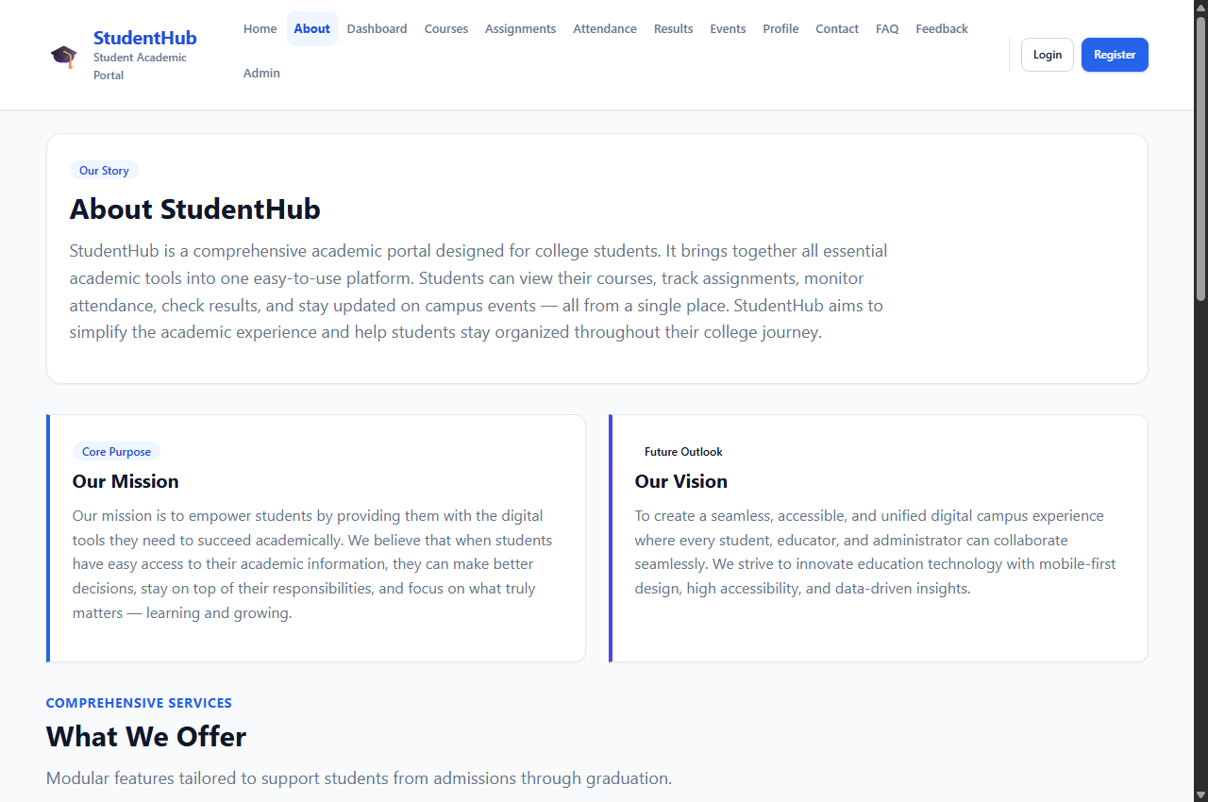 | 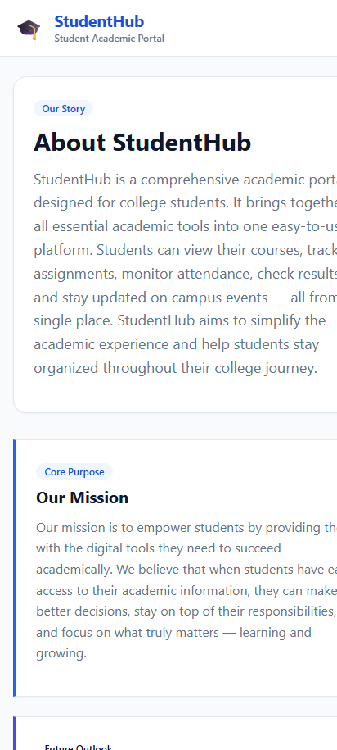

Complete Source Code:
<!DOCTYPE html>
<html lang="en">
<head>
<meta charset="UTF-8">
<meta name="viewport" content="width=device-width, initial-scale=1.0">
<meta name="description" content="Learn about StudentHub, our mission, what we offer, and meet our team.">
<title>About - StudentHub</title>
<link rel="stylesheet" href="../css/style.css">
</head>
<body>

<a href="#main-content" class="skip-link">Skip to main content</a>

<!-- Site Header with Flexbox Navigation -->
<header class="site-header">
<div class="container header-inner">
<a href="../index.html" class="brand">
<span class="brand-icon" aria-hidden="true">&#127891;</span>
<div class="brand-text">
<h1>StudentHub</h1>
<p>Student Academic Portal</p>
</div>
</a>

<!-- Mobile Navigation Toggle -->
<button class="nav-toggle" aria-label="Toggle navigation menu" aria-expanded="false">
<span></span>
<span></span>
<span></span>
</button>

<!-- Navigation Links -->
<nav class="nav-menu" aria-label="Main navigation">
<ul class="nav-links">
<li><a href="../index.html" class="nav-link">Home</a></li>
<li><a href="about.html" class="nav-link active">About</a></li>
<li><a href="dashboard.html" class="nav-link">Dashboard</a></li>
<li><a href="courses.html" class="nav-link">Courses</a></li>
<li><a href="assignment.html" class="nav-link">Assignments</a></li>
<li><a href="attendance.html" class="nav-link">Attendance</a></li>
<li><a href="result.html" class="nav-link">Results</a></li>
<li><a href="events.html" class="nav-link">Events</a></li>
<li><a href="profile.html" class="nav-link">Profile</a></li>
<li><a href="contact.html" class="nav-link">Contact</a></li>
<li><a href="faq.html" class="nav-link">FAQ</a></li>
<li><a href="feedback.html" class="nav-link">Feedback</a></li>
<li><a href="admin.html" class="nav-link">Admin</a></li>
</ul>
<div class="nav-auth-buttons">
<a href="login.html" class="btn btn-outline btn-sm">Login</a>
<a href="register.html" class="btn btn-primary btn-sm">Register</a>
</div>
</nav>
</div>
</header>

<main id="main-content" class="site-main">
<div class="container">

<!-- About Intro Hero -->
<section class="about-hero" aria-labelledby="about-intro-heading">
<span class="badge badge-primary" style="margin-bottom: 0.75rem;">Our Story</span>
<h2 id="about-intro-heading" style="font-size: var(--font-size-2xl);">About StudentHub</h2>
<p style="font-size: var(--font-size-md); max-width: 900px; color: var(--color-text-muted);">
StudentHub is a comprehensive academic portal designed for college students. It brings together
all essential academic tools into one easy-to-use platform. Students can view their courses,
track assignments, monitor attendance, check results, and stay updated on campus events — all
from a single place. StudentHub aims to simplify the academic experience and help students
stay organized throughout their college journey.
</p>
</section>

<!-- Mission & Vision using CSS Grid -->
<section class="about-mission-grid" aria-labelledby="mission-heading">
<article class="mission-box">
<span class="badge badge-primary" style="margin-bottom: 0.5rem;">Core Purpose</span>
<h3 id="mission-heading">Our Mission</h3>
<p>
Our mission is to empower students by providing them with the digital tools they need to
succeed academically. We believe that when students have easy access to their academic
information, they can make better decisions, stay on top of their responsibilities, and
focus on what truly matters — learning and growing.
</p>
</article>

<article class="mission-box" style="border-left-color: var(--color-secondary);">
<span class="badge badge-secondary" style="margin-bottom: 0.5rem;">Future Outlook</span>
<h3>Our Vision</h3>
<p>
To create a seamless, accessible, and unified digital campus experience where every student,
educator, and administrator can collaborate seamlessly. We strive to innovate education
technology with mobile-first design, high accessibility, and data-driven insights.
</p>
</article>
</section>

<!-- What We Offer using CSS Grid -->
<section style="margin-bottom: var(--space-12);" aria-labelledby="offer-heading">
<div class="section-title-wrap">
<p class="section-subtitle">Comprehensive Services</p>
<h2 id="offer-heading">What We Offer</h2>
<p class="section-desc">Modular features tailored to support students from admissions through graduation.</p>
</div>

<div class="grid-responsive-cards">
<div class="card">
<div class="feature-icon-box" aria-hidden="true">&#128218;</div>
<h3>Course Management</h3>
<p>View enrolled courses, semester schedules, lecture venues, and faculty contact information at a glance.</p>
</div>

<div class="card">
<div class="feature-icon-box" aria-hidden="true">&#9201;</div>
<h3>Assignment Tracking</h3>
<p>Keep track of submission deadlines, homework files, project rubrics, and professor evaluation remarks.</p>
</div>

<div class="card">
<div class="feature-icon-box" aria-hidden="true">&#128200;</div>
<h3>Attendance Monitoring</h3>
<p>Real-time calculation of your attendance percentage per subject with automatic shortage warning alerts.</p>
</div>

<div class="card">
<div class="feature-icon-box" aria-hidden="true">&#128220;</div>
<h3>Result &amp; GPA Reports</h3>
<p>Instant access to semester marks, SGPA breakdown, and downloadable official grade sheets.</p>
</div>

<div class="card">
<div class="feature-icon-box" aria-hidden="true">&#127917;</div>
<h3>Event Discovery</h3>
<p>Stay informed about university fests, inter-college hackathons, guest seminars, and workshops.</p>
</div>

<div class="card">
<div class="feature-icon-box" aria-hidden="true">&#128100;</div>
<h3>Profile &amp; Credentials</h3>
<p>Keep your profile, academic branch, roll number, and official emergency contacts synchronized.</p>
</div>
</div>
</section>

<!-- Our Team using CSS Grid & Responsive Table -->
<section aria-labelledby="team-heading">
<div class="section-title-wrap">
<p class="section-subtitle">Leadership &amp; Creators</p>
<h2 id="team-heading">Our Team</h2>
<p class="section-desc">Meet the passionate educators and developers building and maintaining StudentHub.</p>
</div>

<!-- Team Grid with Visual Cards -->
<div class="team-grid" style="margin-bottom: var(--space-6);">
<div class="team-card">
<div class="team-avatar" aria-hidden="true">&#128104;&#8205;&#127979;</div>
<h3 class="team-name">Dr. Arvind Sharma</h3>
<span class="badge badge-primary team-role">Project Lead</span>
<p class="team-dept">Department of Computer Science</p>
</div>

<div class="team-card">
<div class="team-avatar" aria-hidden="true">&#128105;&#8205;&#128187;</div>
<h3 class="team-name">Priya Nair</h3>
<span class="badge badge-info team-role">Frontend Developer</span>
<p class="team-dept">Information Technology</p>
</div>

<div class="team-card">
<div class="team-avatar" aria-hidden="true">&#128104;&#8205;&#128187;</div>
<h3 class="team-name">Rohan Mehta</h3>
<span class="badge badge-secondary team-role">Backend Developer</span>
<p class="team-dept">Department of Computer Science</p>
</div>
</div>

<!-- Semantic Accessible Table -->
<div class="table-responsive">
<table class="data-table">
<thead>
<tr>
<th scope="col">Name</th>
<th scope="col">Role</th>
<th scope="col">Department</th>
<th scope="col">Office</th>
</tr>
</thead>
<tbody>
<tr>
<td><strong>Dr. Arvind Sharma</strong></td>
<td><span class="badge badge-primary">Project Lead</span></td>
<td>Computer Science</td>
<td>CS Block #301</td>
</tr>
<tr>
<td><strong>Priya Nair</strong></td>
<td><span class="badge badge-info">Frontend Developer</span></td>
<td>Information Technology</td>
<td>IT Innovation Lab</td>
</tr>
<tr>
<td><strong>Rohan Mehta</strong></td>
<td><span class="badge badge-secondary">Backend Developer</span></td>
<td>Computer Science</td>
<td>CS Lab 2</td>
</tr>
</tbody>
</table>
</div>
</section>

</div>
</main>

<!-- Site Footer with Flexbox -->
<footer class="site-footer">
<div class="container footer-inner">
<div class="footer-top">
<div class="brand">
<span class="brand-icon" style="filter: brightness(1.2);">&#127891;</span>
<div class="brand-text">
<h2 style="color: #ffffff; font-size: 1.1rem; margin-bottom: 0;">StudentHub</h2>
<p style="color: #94a3b8; font-size: 0.75rem;">Student Academic Portal</p>
</div>
</div>
<ul class="footer-links">
<li><a href="../index.html">Home</a></li>
<li><a href="about.html">About</a></li>
<li><a href="dashboard.html">Dashboard</a></li>
<li><a href="courses.html">Courses</a></li>
<li><a href="events.html">Events</a></li>
<li><a href="contact.html">Contact</a></li>
<li><a href="faq.html">FAQ</a></li>
<li><a href="register.html">Register</a></li>
</ul>
</div>
<div class="footer-bottom">
<p>&copy; 2026 StudentHub. All rights reserved.</p>
<p>Designed with mobile-first CSS Grid &amp; Flexbox for accessibility and performance.</p>
</div>
</div>
</footer>

<script src="../js/main.js"></script>
</body>
</html>

3.3 Registration Page (pages/register.html)
Description: A student registration portal featuring structured personal/academic inputs, password confirmation, terms acceptance, and accessible validation states.
📌 CSS Grid & Flexbox Techniques
• CSS Grid: .form-grid-2 transforms fields into 2 equal columns on tablet/desktop while defaulting to 1 column on mobile devices.
• Flexbox: Centered card container (.auth-wrapper), custom checkbox alignment, and action buttons.

Rendered Output Screenshots (Desktop & Mobile):
💻 Desktop View (1280px) | 📱 Mobile View (412px)
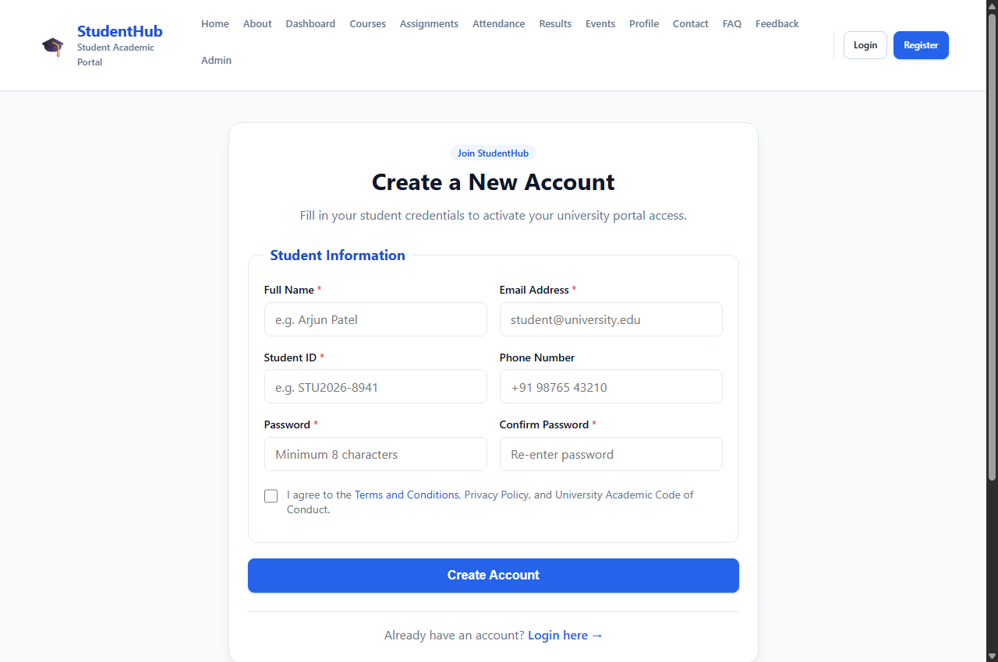 | 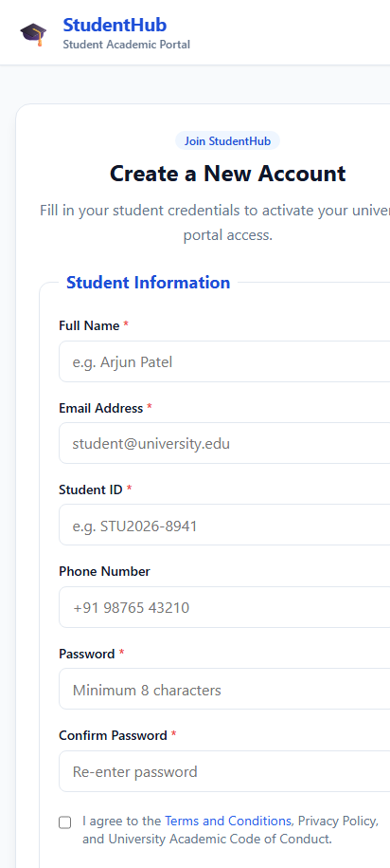

Complete Source Code:
<!DOCTYPE html>
<html lang="en">
<head>
<meta charset="UTF-8">
<meta name="viewport" content="width=device-width, initial-scale=1.0">
<meta name="description" content="Create a new StudentHub account to access your academic portal.">
<title>Register - StudentHub</title>
<link rel="stylesheet" href="../css/style.css">
</head>
<body>

<a href="#main-content" class="skip-link">Skip to main content</a>

<!-- Site Header with Flexbox Navigation -->
<header class="site-header">
<div class="container header-inner">
<a href="../index.html" class="brand">
<span class="brand-icon" aria-hidden="true">&#127891;</span>
<div class="brand-text">
<h1>StudentHub</h1>
<p>Student Academic Portal</p>
</div>
</a>

<!-- Mobile Navigation Toggle -->
<button class="nav-toggle" aria-label="Toggle navigation menu" aria-expanded="false">
<span></span>
<span></span>
<span></span>
</button>

<!-- Navigation Links -->
<nav class="nav-menu" aria-label="Main navigation">
<ul class="nav-links">
<li><a href="../index.html" class="nav-link">Home</a></li>
<li><a href="about.html" class="nav-link">About</a></li>
<li><a href="dashboard.html" class="nav-link">Dashboard</a></li>
<li><a href="courses.html" class="nav-link">Courses</a></li>
<li><a href="assignment.html" class="nav-link">Assignments</a></li>
<li><a href="attendance.html" class="nav-link">Attendance</a></li>
<li><a href="result.html" class="nav-link">Results</a></li>
<li><a href="events.html" class="nav-link">Events</a></li>
<li><a href="profile.html" class="nav-link">Profile</a></li>
<li><a href="contact.html" class="nav-link">Contact</a></li>
<li><a href="faq.html" class="nav-link">FAQ</a></li>
<li><a href="feedback.html" class="nav-link">Feedback</a></li>
<li><a href="admin.html" class="nav-link">Admin</a></li>
</ul>
<div class="nav-auth-buttons">
<a href="login.html" class="btn btn-outline btn-sm">Login</a>
<a href="register.html" class="btn btn-primary btn-sm active">Register</a>
</div>
</nav>
</div>
</header>

<main id="main-content" class="site-main">
<div class="container">
<div class="auth-wrapper">
<div class="auth-card">
<div class="auth-header">
<span class="badge badge-primary" style="margin-bottom: 0.5rem;">Join StudentHub</span>
<h2>Create a New Account</h2>
<p style="margin-bottom: 0;">Fill in your student credentials to activate your university portal access.</p>
</div>

<form action="#" method="post" novalidate>
<fieldset class="form-fieldset">
<legend class="form-legend">Student Information</legend>

<!-- Form Grid using CSS Grid (1 col on mobile, 2 cols on tablet/desktop) -->
<div class="form-grid form-grid-2">
<div class="form-group">
<label for="fullname" class="form-label">Full Name <span style="color: var(--color-danger)">*</span></label>
<input type="text" id="fullname" name="fullname" class="form-control" placeholder="e.g. Arjun Patel" required autocomplete="name">
</div>

<div class="form-group">
<label for="email" class="form-label">Email Address <span style="color: var(--color-danger)">*</span></label>
<input type="email" id="email" name="email" class="form-control" placeholder="student@university.edu" required autocomplete="email">
</div>

<div class="form-group">
<label for="studentid" class="form-label">Student ID <span style="color: var(--color-danger)">*</span></label>
<input type="text" id="studentid" name="studentid" class="form-control" placeholder="e.g. STU2026-8941" required>
</div>

<div class="form-group">
<label for="phone" class="form-label">Phone Number</label>
<input type="tel" id="phone" name="phone" class="form-control" placeholder="+91 98765 43210" autocomplete="tel">
</div>

<div class="form-group">
<label for="password" class="form-label">Password <span style="color: var(--color-danger)">*</span></label>
<input type="password" id="password" name="password" class="form-control" placeholder="Minimum 8 characters" required autocomplete="new-password">
</div>

<div class="form-group">
<label for="confirmpassword" class="form-label">Confirm Password <span style="color: var(--color-danger)">*</span></label>
<input type="password" id="confirmpassword" name="confirmpassword" class="form-control" placeholder="Re-enter password" required autocomplete="new-password">
</div>
</div>

<div class="checkbox-group">
<input type="checkbox" id="terms" name="terms" required>
<label for="terms" class="checkbox-label">
I agree to the <a href="#">Terms and Conditions</a>, Privacy Policy, and University Academic Code of Conduct.
</label>
</div>
</fieldset>

<div style="margin-top: var(--space-4);">
<button type="submit" class="btn btn-primary btn-block" style="font-size: 1rem;">Create Account</button>
</div>
</form>

<div style="text-align: center; margin-top: var(--space-6); padding-top: var(--space-4); border-top: 1px solid var(--color-border);">
<p style="margin-bottom: 0;">Already have an account? <a href="login.html" style="font-weight: 600;">Login here &rarr;</a></p>
</div>
</div>
</div>
</div>
</main>

<!-- Site Footer with Flexbox -->
<footer class="site-footer">
<div class="container footer-inner">
<div class="footer-top">
<div class="brand">
<span class="brand-icon" style="filter: brightness(1.2);">&#127891;</span>
<div class="brand-text">
<h2 style="color: #ffffff; font-size: 1.1rem; margin-bottom: 0;">StudentHub</h2>
<p style="color: #94a3b8; font-size: 0.75rem;">Student Academic Portal</p>
</div>
</div>
<ul class="footer-links">
<li><a href="../index.html">Home</a></li>
<li><a href="about.html">About</a></li>
<li><a href="dashboard.html">Dashboard</a></li>
<li><a href="courses.html">Courses</a></li>
<li><a href="events.html">Events</a></li>
<li><a href="contact.html">Contact</a></li>
<li><a href="faq.html">FAQ</a></li>
<li><a href="login.html">Login</a></li>
</ul>
</div>
<div class="footer-bottom">
<p>&copy; 2026 StudentHub. All rights reserved.</p>
<p>Designed with mobile-first CSS Grid &amp; Flexbox for accessibility and performance.</p>
</div>
</div>
</footer>

<script src="../js/main.js"></script>
</body>
</html>

3.4 Student Dashboard (pages/dashboard.html)
Description: The core operational dashboard for enrolled students, organizing pending assignments, attendance benchmarks, alerts, and navigation links.
📌 CSS Grid & Flexbox Techniques
• CSS Grid: 4-column Academic Summary Cards (Enrolled, Tasks, Attendance, CGPA) + 2-Column Desktop Grid (2.2fr main deadlines table + 1fr alerts sidebar).
• Flexbox: Personalized student header with avatar badge ('AP') and quick shortcut pills.

Rendered Output Screenshots (Desktop & Mobile):
💻 Desktop View (1280px) | 📱 Mobile View (412px)
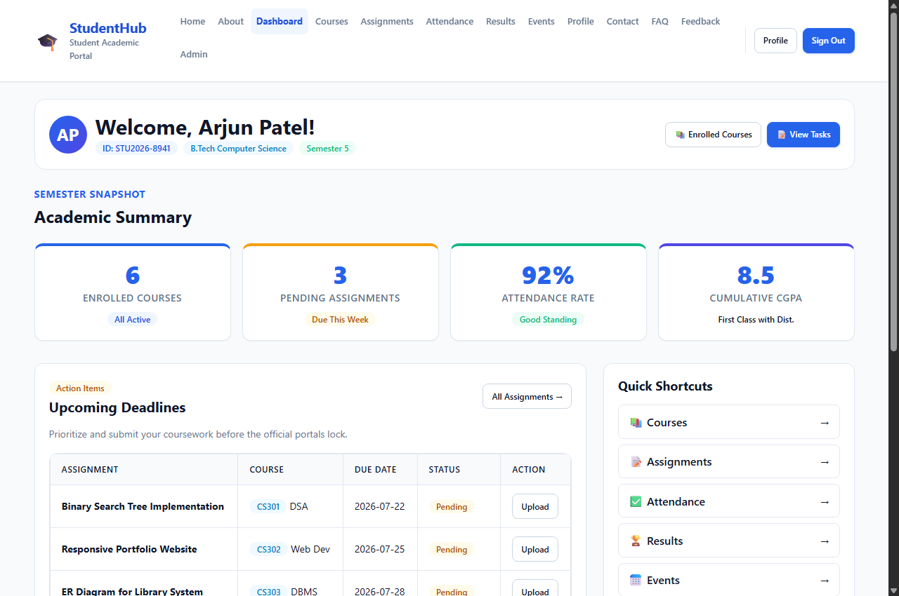 | 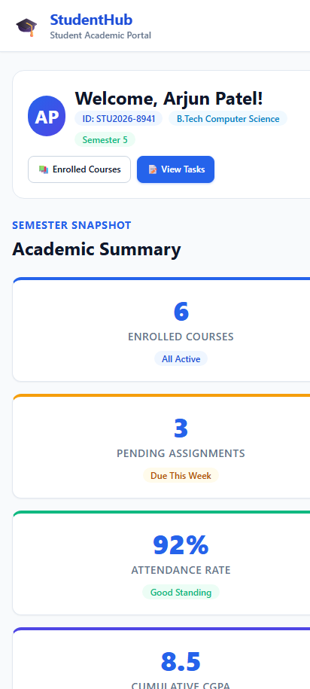

Complete Source Code:
<!DOCTYPE html>
<html lang="en">
<head>
<meta charset="UTF-8">
<meta name="viewport" content="width=device-width, initial-scale=1.0">
<meta name="description" content="StudentHub Dashboard — View your academic summary, upcoming deadlines, and quick links.">
<title>Dashboard — StudentHub</title>
<link rel="stylesheet" href="../css/style.css">
</head>
<body>

<a href="#main-content" class="skip-link">Skip to main content</a>

<!-- Site Header with Flexbox Navigation -->
<header class="site-header">
<div class="container header-inner">
<a href="../index.html" class="brand">
<span class="brand-icon" aria-hidden="true">&#127891;</span>
<div class="brand-text">
<h1>StudentHub</h1>
<p>Student Academic Portal</p>
</div>
</a>

<!-- Mobile Navigation Toggle -->
<button class="nav-toggle" aria-label="Toggle navigation menu" aria-expanded="false">
<span></span>
<span></span>
<span></span>
</button>

<!-- Navigation Links -->
<nav class="nav-menu" aria-label="Main navigation">
<ul class="nav-links">
<li><a href="../index.html" class="nav-link">Home</a></li>
<li><a href="about.html" class="nav-link">About</a></li>
<li><a href="dashboard.html" class="nav-link active">Dashboard</a></li>
<li><a href="courses.html" class="nav-link">Courses</a></li>
<li><a href="assignment.html" class="nav-link">Assignments</a></li>
<li><a href="attendance.html" class="nav-link">Attendance</a></li>
<li><a href="result.html" class="nav-link">Results</a></li>
<li><a href="events.html" class="nav-link">Events</a></li>
<li><a href="profile.html" class="nav-link">Profile</a></li>
<li><a href="contact.html" class="nav-link">Contact</a></li>
<li><a href="faq.html" class="nav-link">FAQ</a></li>
<li><a href="feedback.html" class="nav-link">Feedback</a></li>
<li><a href="admin.html" class="nav-link">Admin</a></li>
</ul>
<div class="nav-auth-buttons">
<a href="profile.html" class="btn btn-outline btn-sm">Profile</a>
<a href="login.html" class="btn btn-primary btn-sm">Sign Out</a>
</div>
</nav>
</div>
</header>

<main id="main-content" class="site-main">
<div class="container">

<!-- Dashboard Welcome Header (Flexbox) -->
<section class="dashboard-header" aria-labelledby="dash-welcome">
<div class="dashboard-user-info">
<div class="dashboard-avatar" aria-hidden="true">AP</div>
<div>
<h2 id="dash-welcome" style="margin-bottom: 0.15rem;">Welcome, Arjun Patel!</h2>
<div style="display: flex; gap: 0.5rem; flex-wrap: wrap; align-items: center;">
<span class="badge badge-primary">ID: STU2026-8941</span>
<span class="badge badge-info">B.Tech Computer Science</span>
<span class="badge badge-success">Semester 5</span>
</div>
</div>
</div>
<div style="display: flex; gap: 0.5rem; flex-wrap: wrap;">
<a href="courses.html" class="btn btn-outline btn-sm">&#128218; Enrolled Courses</a>
<a href="assignment.html" class="btn btn-primary btn-sm">&#128221; View Tasks</a>
</div>
</section>

<!-- Academic Summary Cards (CSS Grid) -->
<section style="margin-bottom: var(--space-8);" aria-labelledby="summary-heading">
<div class="section-title-wrap">
<p class="section-subtitle">Semester Snapshot</p>
<h3 id="summary-heading" style="font-size: var(--font-size-xl);">Academic Summary</h3>
</div>

<div class="grid-stats">
<div class="stat-card" style="border-top: 4px solid var(--color-primary);">
<span class="stat-number">6</span>
<span class="stat-label">Enrolled Courses</span>
<span class="badge badge-primary" style="margin-top: 0.5rem;">All Active</span>
</div>

<div class="stat-card" style="border-top: 4px solid var(--color-warning);">
<span class="stat-number">3</span>
<span class="stat-label">Pending Assignments</span>
<span class="badge badge-warning" style="margin-top: 0.5rem;">Due This Week</span>
</div>

<div class="stat-card" style="border-top: 4px solid var(--color-success);">
<span class="stat-number">92%</span>
<span class="stat-label">Attendance Rate</span>
<span class="badge badge-success" style="margin-top: 0.5rem;">Good Standing</span>
</div>

<div class="stat-card" style="border-top: 4px solid var(--color-secondary);">
<span class="stat-number">8.5</span>
<span class="stat-label">Cumulative CGPA</span>
<span class="badge badge-secondary" style="margin-top: 0.5rem;">First Class with Dist.</span>
</div>
</div>
</section>

<!-- Dashboard 2-Column Responsive Layout using CSS Grid -->
<div class="dashboard-layout">

<!-- Left Main Column: Deadlines Table -->
<section class="card" aria-labelledby="deadlines-heading">
<div class="card-header">
<div>
<span class="badge badge-warning" style="margin-bottom: 0.25rem;">Action Items</span>
<h3 id="deadlines-heading" style="margin-bottom: 0;">Upcoming Deadlines</h3>
</div>
<a href="assignment.html" class="btn btn-sm btn-outline">All Assignments &rarr;</a>
</div>

<div class="card-body">
<p style="font-size: var(--font-size-sm); margin-bottom: var(--space-4);">
Prioritize and submit your coursework before the official portals lock.
</p>

<div class="table-responsive" style="margin-bottom: 0;">
<table class="data-table">
<thead>
<tr>
<th scope="col">Assignment</th>
<th scope="col">Course</th>
<th scope="col">Due Date</th>
<th scope="col">Status</th>
<th scope="col">Action</th>
</tr>
</thead>
<tbody>
<tr>
<td><strong>Binary Search Tree Implementation</strong></td>
<td><span class="badge badge-info">CS301</span> DSA</td>
<td>2026-07-22</td>
<td><span class="badge badge-warning">Pending</span></td>
<td><a href="assignment.html" class="btn btn-sm btn-outline">Upload</a></td>
</tr>
<tr>
<td><strong>Responsive Portfolio Website</strong></td>
<td><span class="badge badge-info">CS302</span> Web Dev</td>
<td>2026-07-25</td>
<td><span class="badge badge-warning">Pending</span></td>
<td><a href="assignment.html" class="btn btn-sm btn-outline">Upload</a></td>
</tr>
<tr>
<td><strong>ER Diagram for Library System</strong></td>
<td><span class="badge badge-info">CS303</span> DBMS</td>
<td>2026-07-28</td>
<td><span class="badge badge-warning">Pending</span></td>
<td><a href="assignment.html" class="btn btn-sm btn-outline">Upload</a></td>
</tr>
<tr>
<td><strong>Process Scheduling Simulation</strong></td>
<td><span class="badge badge-info">CS304</span> OS</td>
<td>2026-08-01</td>
<td><span class="badge badge-danger">Not Started</span></td>
<td><a href="assignment.html" class="btn btn-sm btn-outline">Start</a></td>
</tr>
</tbody>
</table>
</div>
</div>
</section>

<!-- Right Sidebar Column: Quick Links & Alerts -->
<aside style="display: flex; flex-direction: column; gap: var(--space-6);" aria-labelledby="quicklinks-heading">

<!-- Quick Navigation Card -->
<div class="card">
<div class="card-header">
<h3 id="quicklinks-heading" style="margin-bottom: 0; font-size: var(--font-size-md);">Quick Shortcuts</h3>
</div>
<div class="card-body">
<div class="grid grid-cols-1" style="gap: var(--space-2);">
<a href="courses.html" class="quick-link-item" style="padding: 0.65rem 0.85rem;">
<span>&#128218; Courses</span>
<span aria-hidden="true">&rarr;</span>
</a>
<a href="assignment.html" class="quick-link-item" style="padding: 0.65rem 0.85rem;">
<span>&#128221; Assignments</span>
<span aria-hidden="true">&rarr;</span>
</a>
<a href="attendance.html" class="quick-link-item" style="padding: 0.65rem 0.85rem;">
<span>&#9989; Attendance</span>
<span aria-hidden="true">&rarr;</span>
</a>
<a href="result.html" class="quick-link-item" style="padding: 0.65rem 0.85rem;">
<span>&#127942; Results</span>
<span aria-hidden="true">&rarr;</span>
</a>
<a href="events.html" class="quick-link-item" style="padding: 0.65rem 0.85rem;">
<span>&#128197; Events</span>
<span aria-hidden="true">&rarr;</span>
</a>
<a href="profile.html" class="quick-link-item" style="padding: 0.65rem 0.85rem;">
<span>&#128100; Profile</span>
<span aria-hidden="true">&rarr;</span>
</a>
</div>
</div>
</div>

<!-- Campus Notices Card -->
<div class="card" style="background-color: var(--color-primary-light); border-color: #bfdbfe;">
<h4 style="color: var(--color-primary-dark); font-size: var(--font-size-md);">Campus Notice</h4>
<p style="font-size: var(--font-size-sm); color: #1e3a8a; margin-bottom: var(--space-3);">
Mid-term practical examinations begin on August 15th. Check course portals for lab venue allocations.
</p>
<a href="events.html" class="btn btn-sm btn-primary">Check Calendar &rarr;</a>
</div>

</aside>

</div>

</div>
</main>

<!-- Site Footer with Flexbox -->
<footer class="site-footer">
<div class="container footer-inner">
<div class="footer-top">
<div class="brand">
<span class="brand-icon" style="filter: brightness(1.2);">&#127891;</span>
<div class="brand-text">
<h2 style="color: #ffffff; font-size: 1.1rem; margin-bottom: 0;">StudentHub</h2>
<p style="color: #94a3b8; font-size: 0.75rem;">Student Academic Portal</p>
</div>
</div>
<ul class="footer-links">
<li><a href="../index.html">Home</a></li>
<li><a href="about.html">About</a></li>
<li><a href="dashboard.html">Dashboard</a></li>
<li><a href="courses.html">Courses</a></li>
<li><a href="events.html">Events</a></li>
<li><a href="contact.html">Contact</a></li>
<li><a href="faq.html">FAQ</a></li>
<li><a href="profile.html">Profile</a></li>
</ul>
</div>
<div class="footer-bottom">
<p>&copy; 2026 StudentHub. All rights reserved.</p>
<p>Designed with mobile-first CSS Grid &amp; Flexbox for accessibility and performance.</p>
</div>
</div>
</footer>

<script src="../js/main.js"></script>
</body>
</html>

3.5 Campus Events Page (pages/events.html)
Description: Highlights university workshops, hackathons, guest lectures, and cultural nights with direct registration CTAs.
📌 CSS Grid & Flexbox Techniques
• Flexbox: Filter category bar with interactive pills (Technical, Cultural, Sports, Workshops).
• CSS Grid: 3-column Event Cards with dual-tier calendar date badges (Day/Month), venue icons, and responsive tabular calendar overview.

Rendered Output Screenshots (Desktop & Mobile):
💻 Desktop View (1280px) | 📱 Mobile View (412px)
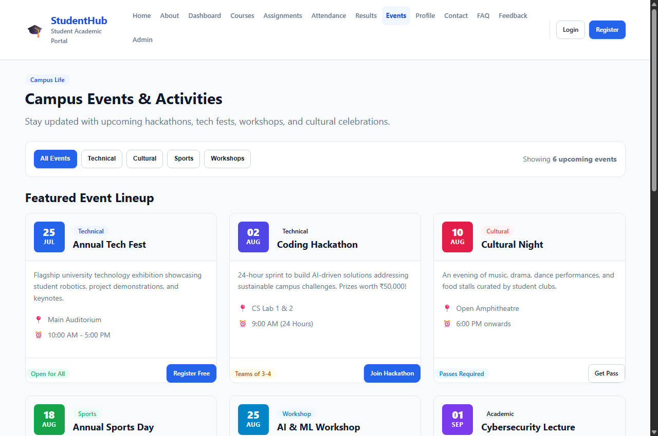 | 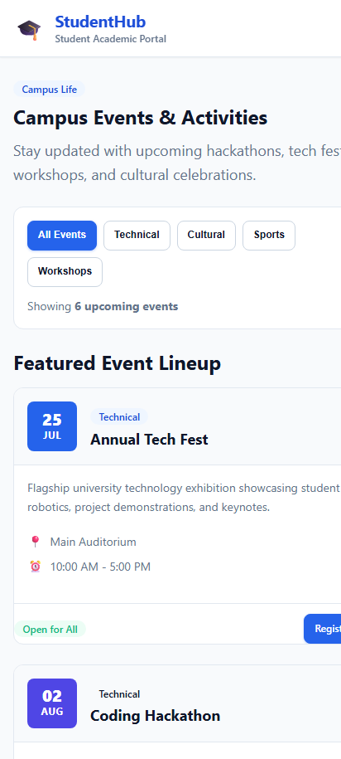

Complete Source Code:
<!DOCTYPE html>
<html lang="en">
<head>
<meta charset="UTF-8">
<meta name="viewport" content="width=device-width, initial-scale=1.0">
<meta name="description" content="StudentHub - Campus Events, Workshops, Competitions, and Activities">
<title>Events - StudentHub</title>
<link rel="stylesheet" href="../css/style.css">
</head>
<body>

<a href="#main-content" class="skip-link">Skip to main content</a>

<!-- Site Header with Flexbox Navigation -->
<header class="site-header">
<div class="container header-inner">
<a href="../index.html" class="brand">
<span class="brand-icon" aria-hidden="true">&#127891;</span>
<div class="brand-text">
<h1>StudentHub</h1>
<p>Student Academic Portal</p>
</div>
</a>

<!-- Mobile Navigation Toggle -->
<button class="nav-toggle" aria-label="Toggle navigation menu" aria-expanded="false">
<span></span>
<span></span>
<span></span>
</button>

<!-- Navigation Links -->
<nav class="nav-menu" aria-label="Main navigation">
<ul class="nav-links">
<li><a href="../index.html" class="nav-link">Home</a></li>
<li><a href="about.html" class="nav-link">About</a></li>
<li><a href="dashboard.html" class="nav-link">Dashboard</a></li>
<li><a href="courses.html" class="nav-link">Courses</a></li>
<li><a href="assignment.html" class="nav-link">Assignments</a></li>
<li><a href="attendance.html" class="nav-link">Attendance</a></li>
<li><a href="result.html" class="nav-link">Results</a></li>
<li><a href="events.html" class="nav-link active">Events</a></li>
<li><a href="profile.html" class="nav-link">Profile</a></li>
<li><a href="contact.html" class="nav-link">Contact</a></li>
<li><a href="faq.html" class="nav-link">FAQ</a></li>
<li><a href="feedback.html" class="nav-link">Feedback</a></li>
<li><a href="admin.html" class="nav-link">Admin</a></li>
</ul>
<div class="nav-auth-buttons">
<a href="login.html" class="btn btn-outline btn-sm">Login</a>
<a href="register.html" class="btn btn-primary btn-sm">Register</a>
</div>
</nav>
</div>
</header>

<main id="main-content" class="site-main">
<div class="container">

<!-- Events Header & Intro -->
<section style="margin-bottom: var(--space-6);" aria-labelledby="events-heading">
<div class="section-title-wrap">
<span class="badge badge-primary" style="margin-bottom: 0.5rem;">Campus Life</span>
<h2 id="events-heading">Campus Events &amp; Activities</h2>
<p class="section-desc">Stay updated with upcoming hackathons, tech fests, workshops, and cultural celebrations.</p>
</div>

<!-- Filter Bar using Flexbox -->
<div class="events-filter-bar">
<div style="display: flex; gap: 0.5rem; flex-wrap: wrap;">
<button class="btn btn-sm btn-primary">All Events</button>
<button class="btn btn-sm btn-outline">Technical</button>
<button class="btn btn-sm btn-outline">Cultural</button>
<button class="btn btn-sm btn-outline">Sports</button>
<button class="btn btn-sm btn-outline">Workshops</button>
</div>
<div style="font-size: var(--font-size-sm); color: var(--color-text-muted);">
Showing <strong>6 upcoming events</strong>
</div>
</div>
</section>

<!-- Events Cards Grid using CSS Grid -->
<section style="margin-bottom: var(--space-10);" aria-labelledby="upcoming-cards-heading">
<h3 id="upcoming-cards-heading" style="margin-bottom: var(--space-4); font-size: var(--font-size-xl);">Featured Event Lineup</h3>

<div class="grid-responsive-cards" style="margin-bottom: var(--space-8);">

<!-- Event 1 -->
<article class="event-card">
<div class="event-card-header">
<div class="event-date-badge">
<span class="event-date-day">25</span>
<span class="event-date-month">Jul</span>
</div>
<div>
<span class="badge badge-primary">Technical</span>
<h3 style="font-size: var(--font-size-md); margin-top: 0.25rem; margin-bottom: 0;">Annual Tech Fest</h3>
</div>
</div>
<div class="event-card-body">
<p style="font-size: var(--font-size-sm); margin-bottom: var(--space-3);">
Flagship university technology exhibition showcasing student robotics, project demonstrations, and keynotes.
</p>
<div class="event-meta-item">
<span aria-hidden="true">&#128205;</span>
<span>Main Auditorium</span>
</div>
<div class="event-meta-item">
<span aria-hidden="true">&#9200;</span>
<span>10:00 AM - 5:00 PM</span>
</div>
</div>
<div class="card-footer">
<span class="badge badge-success">Open for All</span>
<a href="#" class="btn btn-sm btn-primary">Register Free</a>
</div>
</article>

<!-- Event 2 -->
<article class="event-card">
<div class="event-card-header">
<div class="event-date-badge" style="background: var(--color-secondary);">
<span class="event-date-day">02</span>
<span class="event-date-month">Aug</span>
</div>
<div>
<span class="badge badge-secondary">Technical</span>
<h3 style="font-size: var(--font-size-md); margin-top: 0.25rem; margin-bottom: 0;">Coding Hackathon</h3>
</div>
</div>
<div class="event-card-body">
<p style="font-size: var(--font-size-sm); margin-bottom: var(--space-3);">
24-hour sprint to build AI-driven solutions addressing sustainable campus challenges. Prizes worth ₹50,000!
</p>
<div class="event-meta-item">
<span aria-hidden="true">&#128205;</span>
<span>CS Lab 1 &amp; 2</span>
</div>
<div class="event-meta-item">
<span aria-hidden="true">&#9200;</span>
<span>9:00 AM (24 Hours)</span>
</div>
</div>
<div class="card-footer">
<span class="badge badge-warning">Teams of 3-4</span>
<a href="#" class="btn btn-sm btn-primary">Join Hackathon</a>
</div>
</article>

<!-- Event 3 -->
<article class="event-card">
<div class="event-card-header">
<div class="event-date-badge" style="background: #e11d48;">
<span class="event-date-day">10</span>
<span class="event-date-month">Aug</span>
</div>
<div>
<span class="badge badge-danger">Cultural</span>
<h3 style="font-size: var(--font-size-md); margin-top: 0.25rem; margin-bottom: 0;">Cultural Night</h3>
</div>
</div>
<div class="event-card-body">
<p style="font-size: var(--font-size-sm); margin-bottom: var(--space-3);">
An evening of music, drama, dance performances, and food stalls curated by student clubs.
</p>
<div class="event-meta-item">
<span aria-hidden="true">&#128205;</span>
<span>Open Amphitheatre</span>
</div>
<div class="event-meta-item">
<span aria-hidden="true">&#9200;</span>
<span>6:00 PM onwards</span>
</div>
</div>
<div class="card-footer">
<span class="badge badge-info">Passes Required</span>
<a href="#" class="btn btn-sm btn-outline">Get Pass</a>
</div>
</article>

<!-- Event 4 -->
<article class="event-card">
<div class="event-card-header">
<div class="event-date-badge" style="background: #16a34a;">
<span class="event-date-day">18</span>
<span class="event-date-month">Aug</span>
</div>
<div>
<span class="badge badge-success">Sports</span>
<h3 style="font-size: var(--font-size-md); margin-top: 0.25rem; margin-bottom: 0;">Annual Sports Day</h3>
</div>
</div>
<div class="event-card-body">
<p style="font-size: var(--font-size-sm); margin-bottom: var(--space-3);">
Inter-department athletic tournaments including football, cricket, track sprints, and badminton.
</p>
<div class="event-meta-item">
<span aria-hidden="true">&#128205;</span>
<span>University Ground</span>
</div>
<div class="event-meta-item">
<span aria-hidden="true">&#9200;</span>
<span>8:00 AM - 4:00 PM</span>
</div>
</div>
<div class="card-footer">
<span class="badge badge-success">Participant Signups</span>
<a href="#" class="btn btn-sm btn-outline">Enroll Team</a>
</div>
</article>

<!-- Event 5 -->
<article class="event-card">
<div class="event-card-header">
<div class="event-date-badge" style="background: #0284c7;">
<span class="event-date-day">25</span>
<span class="event-date-month">Aug</span>
</div>
<div>
<span class="badge badge-info">Workshop</span>
<h3 style="font-size: var(--font-size-md); margin-top: 0.25rem; margin-bottom: 0;">AI &amp; ML Workshop</h3>
</div>
</div>
<div class="event-card-body">
<p style="font-size: var(--font-size-sm); margin-bottom: var(--space-3);">
Hands-on practical masterclass exploring transformer architectures and fine-tuning neural networks.
</p>
<div class="event-meta-item">
<span aria-hidden="true">&#128205;</span>
<span>Seminar Hall</span>
</div>
<div class="event-meta-item">
<span aria-hidden="true">&#9200;</span>
<span>2:00 PM - 5:30 PM</span>
</div>
</div>
<div class="card-footer">
<span class="badge badge-warning">Limited 60 Seats</span>
<a href="#" class="btn btn-sm btn-primary">Reserve Spot</a>
</div>
</article>

<!-- Event 6 -->
<article class="event-card">
<div class="event-card-header">
<div class="event-date-badge" style="background: #7c3aed;">
<span class="event-date-day">01</span>
<span class="event-date-month">Sep</span>
</div>
<div>
<span class="badge badge-secondary">Academic</span>
<h3 style="font-size: var(--font-size-md); margin-top: 0.25rem; margin-bottom: 0;">Cybersecurity Lecture</h3>
</div>
</div>
<div class="event-card-body">
<p style="font-size: var(--font-size-sm); margin-bottom: var(--space-3);">
Distinguished guest session by industry security architect on zero-trust cloud infrastructure.
</p>
<div class="event-meta-item">
<span aria-hidden="true">&#128205;</span>
<span>Lecture Hall 1</span>
</div>
<div class="event-meta-item">
<span aria-hidden="true">&#9200;</span>
<span>11:00 AM - 1:00 PM</span>
</div>
</div>
<div class="card-footer">
<span class="badge badge-primary">Certificate Provided</span>
<a href="#" class="btn btn-sm btn-outline">Attend Lecture</a>
</div>
</article>

</div>
</section>

<!-- Complete Schedule Table (Mobile Responsive) -->
<section aria-labelledby="schedule-table-heading">
<div class="section-title-wrap">
<p class="section-subtitle">Calendar Overview</p>
<h3 id="schedule-table-heading" style="font-size: var(--font-size-xl);">All Events Schedule</h3>
</div>

<div class="table-responsive">
<table class="data-table">
<thead>
<tr>
<th scope="col">Date</th>
<th scope="col">Event Name</th>
<th scope="col">Type</th>
<th scope="col">Venue</th>
<th scope="col">Time</th>
<th scope="col">Action</th>
</tr>
</thead>
<tbody>
<tr>
<td><strong>25 Jul 2026</strong></td>
<td>Annual Tech Fest</td>
<td><span class="badge badge-primary">Technical</span></td>
<td>Main Auditorium</td>
<td>10:00 AM</td>
<td><a href="#" class="btn btn-sm btn-outline">Details</a></td>
</tr>
<tr>
<td><strong>02 Aug 2026</strong></td>
<td>Coding Hackathon</td>
<td><span class="badge badge-secondary">Technical</span></td>
<td>CS Lab</td>
<td>9:00 AM</td>
<td><a href="#" class="btn btn-sm btn-outline">Details</a></td>
</tr>
<tr>
<td><strong>10 Aug 2026</strong></td>
<td>Cultural Night</td>
<td><span class="badge badge-danger">Cultural</span></td>
<td>Open Amphitheatre</td>
<td>6:00 PM</td>
<td><a href="#" class="btn btn-sm btn-outline">Details</a></td>
</tr>
<tr>
<td><strong>18 Aug 2026</strong></td>
<td>Sports Day</td>
<td><span class="badge badge-success">Sports</span></td>
<td>University Ground</td>
<td>8:00 AM</td>
<td><a href="#" class="btn btn-sm btn-outline">Details</a></td>
</tr>
<tr>
<td><strong>25 Aug 2026</strong></td>
<td>AI Workshop</td>
<td><span class="badge badge-info">Workshop</span></td>
<td>Seminar Hall</td>
<td>2:00 PM</td>
<td><a href="#" class="btn btn-sm btn-outline">Details</a></td>
</tr>
<tr>
<td><strong>01 Sep 2026</strong></td>
<td>Guest Lecture: Cybersecurity</td>
<td><span class="badge badge-primary">Academic</span></td>
<td>Lecture Hall 1</td>
<td>11:00 AM</td>
<td><a href="#" class="btn btn-sm btn-outline">Details</a></td>
</tr>
</tbody>
</table>
</div>
</section>

</div>
</main>

<!-- Site Footer with Flexbox -->
<footer class="site-footer">
<div class="container footer-inner">
<div class="footer-top">
<div class="brand">
<span class="brand-icon" style="filter: brightness(1.2);">&#127891;</span>
<div class="brand-text">
<h2 style="color: #ffffff; font-size: 1.1rem; margin-bottom: 0;">StudentHub</h2>
<p style="color: #94a3b8; font-size: 0.75rem;">Student Academic Portal</p>
</div>
</div>
<ul class="footer-links">
<li><a href="../index.html">Home</a></li>
<li><a href="about.html">About</a></li>
<li><a href="dashboard.html">Dashboard</a></li>
<li><a href="courses.html">Courses</a></li>
<li><a href="events.html">Events</a></li>
<li><a href="contact.html">Contact</a></li>
<li><a href="faq.html">FAQ</a></li>
<li><a href="register.html">Register</a></li>
</ul>
</div>
<div class="footer-bottom">
<p>&copy; 2026 StudentHub. All rights reserved.</p>
<p>Designed with mobile-first CSS Grid &amp; Flexbox for accessibility and performance.</p>
</div>
</div>
</footer>

<script src="../js/main.js"></script>
</body>
</html>

3.6 Course Catalog (pages/courses.html)
Description: Semester 5 curriculum catalog detailing course codes, subject names, credit ratings, and faculty coordinators.
📌 CSS Grid & Flexbox Techniques
• CSS Grid: 4 snapshot metrics for semester terms and credits.
• Flexbox: Table cell alignments, course code badges (CS301-CS306), and direct assignment links.

Before vs After Transformation:
⚠️ Before Fix: Unstyled raw table stretching infinitely across the viewport:
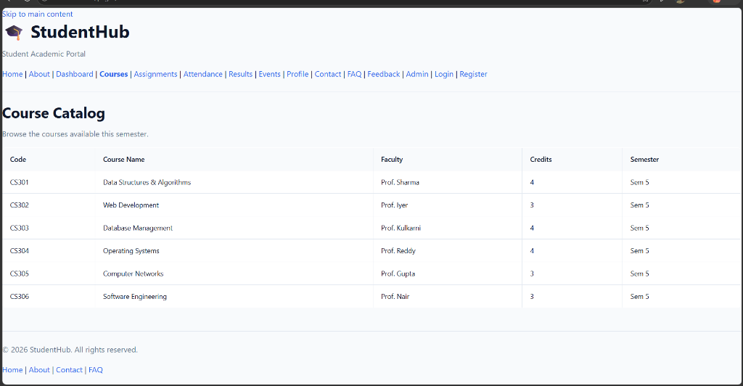

Rendered Output Screenshots (Desktop & Mobile):
💻 Desktop View (1280px) | 📱 Mobile View (412px)
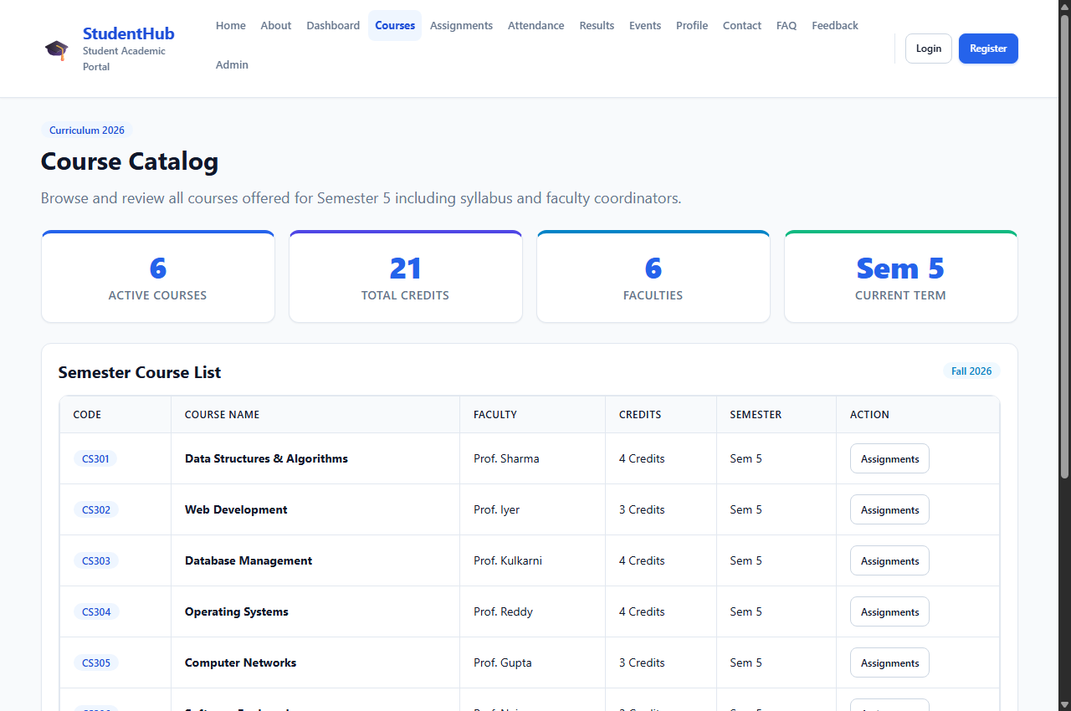 | 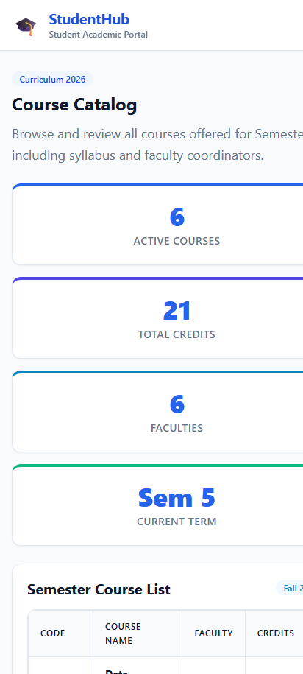

Complete Source Code:
<!DOCTYPE html>
<html lang="en">
<head>
<meta charset="UTF-8">
<meta name="viewport" content="width=device-width, initial-scale=1.0">
<meta name="description" content="StudentHub Courses — Browse the courses available this semester.">
<title>Courses — StudentHub</title>
<link rel="stylesheet" href="../css/style.css">
</head>
<body>

<a href="#main-content" class="skip-link">Skip to main content</a>

<!-- Site Header with Flexbox Navigation -->
<header class="site-header">
<div class="container header-inner">
<a href="../index.html" class="brand">
<span class="brand-icon" aria-hidden="true">&#127891;</span>
<div class="brand-text">
<h1>StudentHub</h1>
<p>Student Academic Portal</p>
</div>
</a>

<!-- Mobile Navigation Toggle -->
<button class="nav-toggle" aria-label="Toggle navigation menu" aria-expanded="false">
<span></span>
<span></span>
<span></span>
</button>

<!-- Navigation Links -->
<nav class="nav-menu" aria-label="Main navigation">
<ul class="nav-links">
<li><a href="../index.html" class="nav-link">Home</a></li>
<li><a href="about.html" class="nav-link">About</a></li>
<li><a href="dashboard.html" class="nav-link">Dashboard</a></li>
<li><a href="courses.html" class="nav-link active">Courses</a></li>
<li><a href="assignment.html" class="nav-link">Assignments</a></li>
<li><a href="attendance.html" class="nav-link">Attendance</a></li>
<li><a href="result.html" class="nav-link">Results</a></li>
<li><a href="events.html" class="nav-link">Events</a></li>
<li><a href="profile.html" class="nav-link">Profile</a></li>
<li><a href="contact.html" class="nav-link">Contact</a></li>
<li><a href="faq.html" class="nav-link">FAQ</a></li>
<li><a href="feedback.html" class="nav-link">Feedback</a></li>
<li><a href="admin.html" class="nav-link">Admin</a></li>
</ul>
<div class="nav-auth-buttons">
<a href="login.html" class="btn btn-outline btn-sm">Login</a>
<a href="register.html" class="btn btn-primary btn-sm">Register</a>
</div>
</nav>
</div>
</header>

<main id="main-content" class="site-main">
<div class="container">

<section class="section-title-wrap" aria-labelledby="courses-heading">
<span class="badge badge-primary" style="margin-bottom: 0.5rem;">Curriculum 2026</span>
<h2 id="courses-heading">Course Catalog</h2>
<p class="section-desc">Browse and review all courses offered for Semester 5 including syllabus and faculty coordinators.</p>
</section>

<!-- Course Metrics Cards using CSS Grid -->
<div class="grid-stats" style="margin-bottom: var(--space-6);">
<div class="stat-card" style="border-top: 4px solid var(--color-primary);">
<span class="stat-number">6</span>
<span class="stat-label">Active Courses</span>
</div>
<div class="stat-card" style="border-top: 4px solid var(--color-secondary);">
<span class="stat-number">21</span>
<span class="stat-label">Total Credits</span>
</div>
<div class="stat-card" style="border-top: 4px solid var(--color-info);">
<span class="stat-number">6</span>
<span class="stat-label">Faculties</span>
</div>
<div class="stat-card" style="border-top: 4px solid var(--color-success);">
<span class="stat-number">Sem 5</span>
<span class="stat-label">Current Term</span>
</div>
</div>

<!-- Responsive Table View inside CSS Scroll Container -->
<div class="card" style="margin-bottom: var(--space-8);">
<div class="card-header">
<h3 style="margin-bottom: 0; font-size: var(--font-size-lg);">Semester Course List</h3>
<span class="badge badge-info">Fall 2026</span>
</div>
<div class="card-body">
<div class="table-responsive" style="margin-bottom: 0;">
<table class="data-table">
<thead>
<tr>
<th scope="col">Code</th>
<th scope="col">Course Name</th>
<th scope="col">Faculty</th>
<th scope="col">Credits</th>
<th scope="col">Semester</th>
<th scope="col">Action</th>
</tr>
</thead>
<tbody>
<tr>
<td><span class="badge badge-primary">CS301</span></td>
<td><strong>Data Structures &amp; Algorithms</strong></td>
<td>Prof. Sharma</td>
<td>4 Credits</td>
<td>Sem 5</td>
<td><a href="assignment.html" class="btn btn-sm btn-outline">Assignments</a></td>
</tr>
<tr>
<td><span class="badge badge-primary">CS302</span></td>
<td><strong>Web Development</strong></td>
<td>Prof. Iyer</td>
<td>3 Credits</td>
<td>Sem 5</td>
<td><a href="assignment.html" class="btn btn-sm btn-outline">Assignments</a></td>
</tr>
<tr>
<td><span class="badge badge-primary">CS303</span></td>
<td><strong>Database Management</strong></td>
<td>Prof. Kulkarni</td>
<td>4 Credits</td>
<td>Sem 5</td>
<td><a href="assignment.html" class="btn btn-sm btn-outline">Assignments</a></td>
</tr>
<tr>
<td><span class="badge badge-primary">CS304</span></td>
<td><strong>Operating Systems</strong></td>
<td>Prof. Reddy</td>
<td>4 Credits</td>
<td>Sem 5</td>
<td><a href="assignment.html" class="btn btn-sm btn-outline">Assignments</a></td>
</tr>
<tr>
<td><span class="badge badge-primary">CS305</span></td>
<td><strong>Computer Networks</strong></td>
<td>Prof. Gupta</td>
<td>3 Credits</td>
<td>Sem 5</td>
<td><a href="assignment.html" class="btn btn-sm btn-outline">Assignments</a></td>
</tr>
<tr>
<td><span class="badge badge-primary">CS306</span></td>
<td><strong>Software Engineering</strong></td>
<td>Prof. Nair</td>
<td>3 Credits</td>
<td>Sem 5</td>
<td><a href="assignment.html" class="btn btn-sm btn-outline">Assignments</a></td>
</tr>
</tbody>
</table>
</div>
</div>
</div>

</div>
</main>

<!-- Site Footer with Flexbox -->
<footer class="site-footer">
<div class="container footer-inner">
<div class="footer-top">
<div class="brand">
<span class="brand-icon" style="filter: brightness(1.2);">&#127891;</span>
<div class="brand-text">
<h2 style="color: #ffffff; font-size: 1.1rem; margin-bottom: 0;">StudentHub</h2>
<p style="color: #94a3b8; font-size: 0.75rem;">Student Academic Portal</p>
</div>
</div>
<ul class="footer-links">
<li><a href="../index.html">Home</a></li>
<li><a href="about.html">About</a></li>
<li><a href="dashboard.html">Dashboard</a></li>
<li><a href="courses.html">Courses</a></li>
<li><a href="events.html">Events</a></li>
<li><a href="contact.html">Contact</a></li>
<li><a href="faq.html">FAQ</a></li>
<li><a href="register.html">Register</a></li>
</ul>
</div>
<div class="footer-bottom">
<p>&copy; 2026 StudentHub. All rights reserved.</p>
<p>Designed with mobile-first CSS Grid &amp; Flexbox for accessibility and performance.</p>
</div>
</div>
</footer>

<script src="../js/main.js"></script>
</body>
</html>

3.7 Assignments Tracker (pages/assignment.html)
Description: Academic task submissions dashboard with deadline monitoring, evaluation marks, and homework upload triggers.
📌 CSS Grid & Flexbox Techniques
• CSS Grid: 4 status cards (Total, Completed, Pending, Overdue).
• Flexbox: Contextual status badges (Graded, Submitted, Pending, Overdue) and action buttons (Upload, Feedback).

Before vs After Transformation:
⚠️ Before Fix: Unstyled raw table stretching infinitely across the viewport:
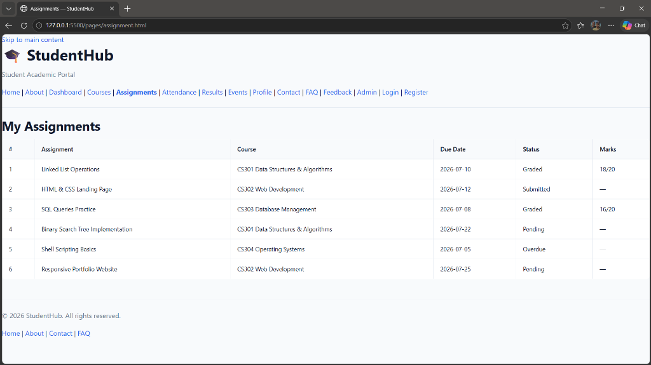

Rendered Output Screenshots (Desktop & Mobile):
💻 Desktop View (1280px) | 📱 Mobile View (412px)
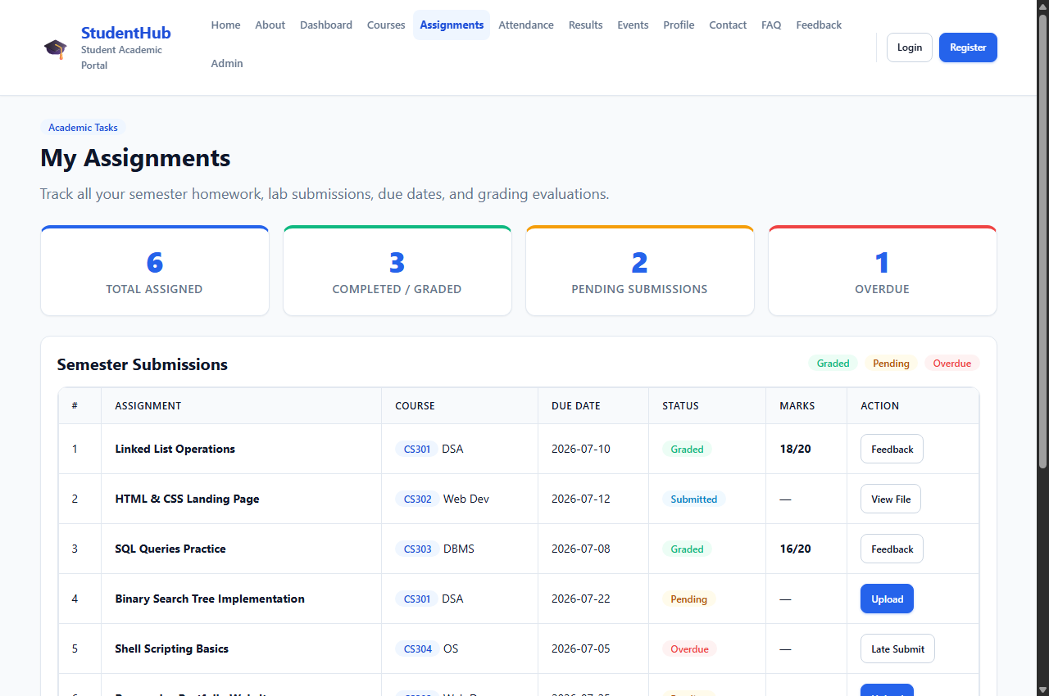 | 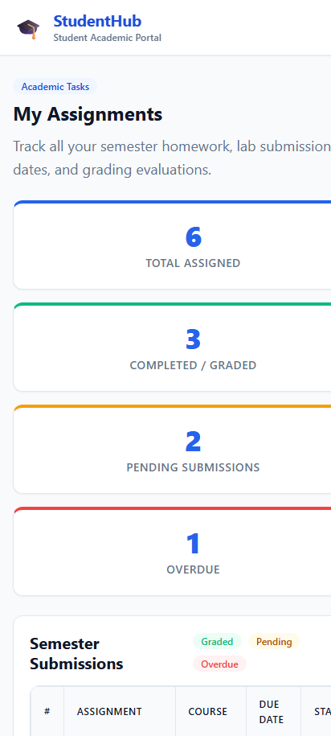

Complete Source Code:
<!DOCTYPE html>
<html lang="en">
<head>
<meta charset="UTF-8">
<meta name="viewport" content="width=device-width, initial-scale=1.0">
<meta name="description" content="StudentHub Assignments — View and track your assignment submissions and deadlines.">
<title>Assignments — StudentHub</title>
<link rel="stylesheet" href="../css/style.css">
</head>
<body>

<a href="#main-content" class="skip-link">Skip to main content</a>

<!-- Site Header with Flexbox Navigation -->
<header class="site-header">
<div class="container header-inner">
<a href="../index.html" class="brand">
<span class="brand-icon" aria-hidden="true">&#127891;</span>
<div class="brand-text">
<h1>StudentHub</h1>
<p>Student Academic Portal</p>
</div>
</a>

<!-- Mobile Navigation Toggle -->
<button class="nav-toggle" aria-label="Toggle navigation menu" aria-expanded="false">
<span></span>
<span></span>
<span></span>
</button>

<!-- Navigation Links -->
<nav class="nav-menu" aria-label="Main navigation">
<ul class="nav-links">
<li><a href="../index.html" class="nav-link">Home</a></li>
<li><a href="about.html" class="nav-link">About</a></li>
<li><a href="dashboard.html" class="nav-link">Dashboard</a></li>
<li><a href="courses.html" class="nav-link">Courses</a></li>
<li><a href="assignment.html" class="nav-link active">Assignments</a></li>
<li><a href="attendance.html" class="nav-link">Attendance</a></li>
<li><a href="result.html" class="nav-link">Results</a></li>
<li><a href="events.html" class="nav-link">Events</a></li>
<li><a href="profile.html" class="nav-link">Profile</a></li>
<li><a href="contact.html" class="nav-link">Contact</a></li>
<li><a href="faq.html" class="nav-link">FAQ</a></li>
<li><a href="feedback.html" class="nav-link">Feedback</a></li>
<li><a href="admin.html" class="nav-link">Admin</a></li>
</ul>
<div class="nav-auth-buttons">
<a href="login.html" class="btn btn-outline btn-sm">Login</a>
<a href="register.html" class="btn btn-primary btn-sm">Register</a>
</div>
</nav>
</div>
</header>

<main id="main-content" class="site-main">
<div class="container">

<section class="section-title-wrap" aria-labelledby="assignments-heading">
<span class="badge badge-primary" style="margin-bottom: 0.5rem;">Academic Tasks</span>
<h2 id="assignments-heading">My Assignments</h2>
<p class="section-desc">Track all your semester homework, lab submissions, due dates, and grading evaluations.</p>
</section>

<!-- Assignment Summary Metrics using CSS Grid -->
<div class="grid-stats" style="margin-bottom: var(--space-6);">
<div class="stat-card" style="border-top: 4px solid var(--color-primary);">
<span class="stat-number">6</span>
<span class="stat-label">Total Assigned</span>
</div>
<div class="stat-card" style="border-top: 4px solid var(--color-success);">
<span class="stat-number">3</span>
<span class="stat-label">Completed / Graded</span>
</div>
<div class="stat-card" style="border-top: 4px solid var(--color-warning);">
<span class="stat-number">2</span>
<span class="stat-label">Pending Submissions</span>
</div>
<div class="stat-card" style="border-top: 4px solid var(--color-danger);">
<span class="stat-number">1</span>
<span class="stat-label">Overdue</span>
</div>
</div>

<!-- Assignments Table inside Card & Responsive Container -->
<div class="card" style="margin-bottom: var(--space-8);">
<div class="card-header">
<h3 style="margin-bottom: 0; font-size: var(--font-size-lg);">Semester Submissions</h3>
<div style="display: flex; gap: 0.5rem; flex-wrap: wrap;">
<span class="badge badge-success">Graded</span>
<span class="badge badge-warning">Pending</span>
<span class="badge badge-danger">Overdue</span>
</div>
</div>

<div class="card-body">
<div class="table-responsive" style="margin-bottom: 0;">
<table class="data-table">
<thead>
<tr>
<th scope="col">#</th>
<th scope="col">Assignment</th>
<th scope="col">Course</th>
<th scope="col">Due Date</th>
<th scope="col">Status</th>
<th scope="col">Marks</th>
<th scope="col">Action</th>
</tr>
</thead>
<tbody>
<tr>
<td>1</td>
<td><strong>Linked List Operations</strong></td>
<td><span class="badge badge-primary">CS301</span> DSA</td>
<td>2026-07-10</td>
<td><span class="badge badge-success">Graded</span></td>
<td><strong>18/20</strong></td>
<td><a href="#" class="btn btn-sm btn-outline">Feedback</a></td>
</tr>
<tr>
<td>2</td>
<td><strong>HTML &amp; CSS Landing Page</strong></td>
<td><span class="badge badge-primary">CS302</span> Web Dev</td>
<td>2026-07-12</td>
<td><span class="badge badge-info">Submitted</span></td>
<td>&mdash;</td>
<td><a href="#" class="btn btn-sm btn-outline">View File</a></td>
</tr>
<tr>
<td>3</td>
<td><strong>SQL Queries Practice</strong></td>
<td><span class="badge badge-primary">CS303</span> DBMS</td>
<td>2026-07-08</td>
<td><span class="badge badge-success">Graded</span></td>
<td><strong>16/20</strong></td>
<td><a href="#" class="btn btn-sm btn-outline">Feedback</a></td>
</tr>
<tr>
<td>4</td>
<td><strong>Binary Search Tree Implementation</strong></td>
<td><span class="badge badge-primary">CS301</span> DSA</td>
<td>2026-07-22</td>
<td><span class="badge badge-warning">Pending</span></td>
<td>&mdash;</td>
<td><a href="#" class="btn btn-sm btn-primary">Upload</a></td>
</tr>
<tr>
<td>5</td>
<td><strong>Shell Scripting Basics</strong></td>
<td><span class="badge badge-primary">CS304</span> OS</td>
<td>2026-07-05</td>
<td><span class="badge badge-danger">Overdue</span></td>
<td>&mdash;</td>
<td><a href="#" class="btn btn-sm btn-outline">Late Submit</a></td>
</tr>
<tr>
<td>6</td>
<td><strong>Responsive Portfolio Website</strong></td>
<td><span class="badge badge-primary">CS302</span> Web Dev</td>
<td>2026-07-25</td>
<td><span class="badge badge-warning">Pending</span></td>
<td>&mdash;</td>
<td><a href="#" class="btn btn-sm btn-primary">Upload</a></td>
</tr>
</tbody>
</table>
</div>
</div>
</div>

</div>
</main>

<!-- Site Footer with Flexbox -->
<footer class="site-footer">
<div class="container footer-inner">
<div class="footer-top">
<div class="brand">
<span class="brand-icon" style="filter: brightness(1.2);">&#127891;</span>
<div class="brand-text">
<h2 style="color: #ffffff; font-size: 1.1rem; margin-bottom: 0;">StudentHub</h2>
<p style="color: #94a3b8; font-size: 0.75rem;">Student Academic Portal</p>
</div>
</div>
<ul class="footer-links">
<li><a href="../index.html">Home</a></li>
<li><a href="about.html">About</a></li>
<li><a href="dashboard.html">Dashboard</a></li>
<li><a href="courses.html">Courses</a></li>
<li><a href="events.html">Events</a></li>
<li><a href="contact.html">Contact</a></li>
<li><a href="faq.html">FAQ</a></li>
<li><a href="register.html">Register</a></li>
</ul>
</div>
<div class="footer-bottom">
<p>&copy; 2026 StudentHub. All rights reserved.</p>
<p>Designed with mobile-first CSS Grid &amp; Flexbox for accessibility and performance.</p>
</div>
</div>
</footer>

<script src="../js/main.js"></script>
</body>
</html>

3.8 Attendance Record (pages/attendance.html)
Description: Real-time lecture and laboratory attendance monitor with automatic eligibility alerts.
📌 CSS Grid & Flexbox Techniques
• CSS Grid: 4 top stat cards replacing the raw vertical table (Total Classes, Attended, Absent, Overall 92%).
• Flexbox: Eligibility badges (>75% mandatory threshold) and subject-wise breakdown.

Before vs After Transformation:
⚠️ Before Fix: Unstyled raw table stretching infinitely across the viewport:
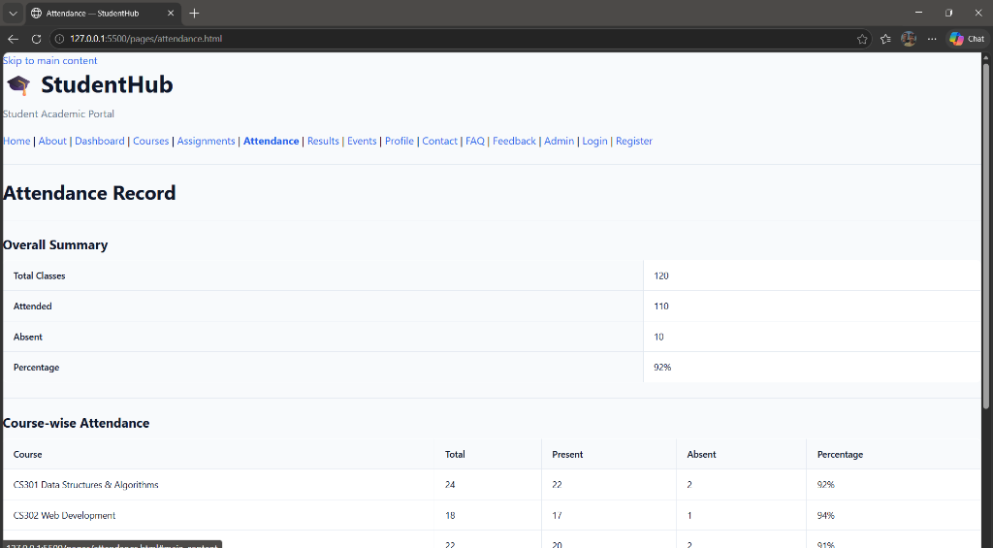

Rendered Output Screenshots (Desktop & Mobile):
💻 Desktop View (1280px) | 📱 Mobile View (412px)
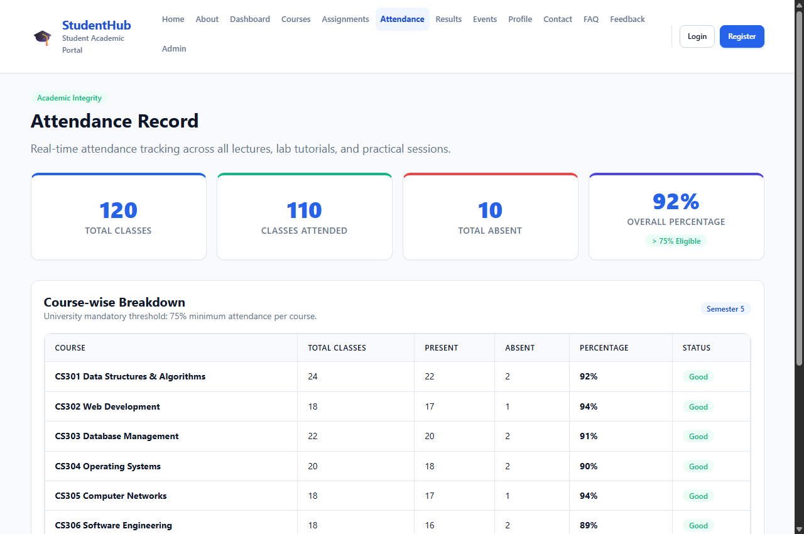 | 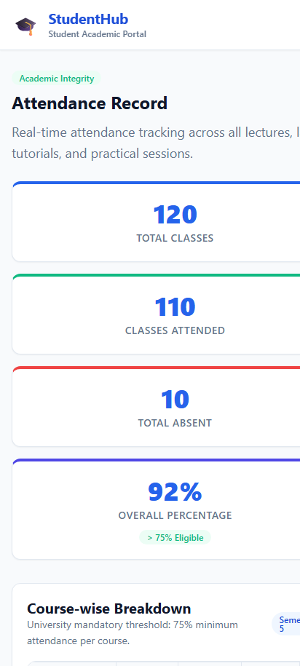

Complete Source Code:
<!DOCTYPE html>
<html lang="en">
<head>
<meta charset="UTF-8">
<meta name="viewport" content="width=device-width, initial-scale=1.0">
<meta name="description" content="StudentHub Attendance — View your overall and course-wise attendance records.">
<title>Attendance — StudentHub</title>
<link rel="stylesheet" href="../css/style.css">
</head>
<body>

<a href="#main-content" class="skip-link">Skip to main content</a>

<!-- Site Header with Flexbox Navigation -->
<header class="site-header">
<div class="container header-inner">
<a href="../index.html" class="brand">
<span class="brand-icon" aria-hidden="true">&#127891;</span>
<div class="brand-text">
<h1>StudentHub</h1>
<p>Student Academic Portal</p>
</div>
</a>

<!-- Mobile Navigation Toggle -->
<button class="nav-toggle" aria-label="Toggle navigation menu" aria-expanded="false">
<span></span>
<span></span>
<span></span>
</button>

<!-- Navigation Links -->
<nav class="nav-menu" aria-label="Main navigation">
<ul class="nav-links">
<li><a href="../index.html" class="nav-link">Home</a></li>
<li><a href="about.html" class="nav-link">About</a></li>
<li><a href="dashboard.html" class="nav-link">Dashboard</a></li>
<li><a href="courses.html" class="nav-link">Courses</a></li>
<li><a href="assignment.html" class="nav-link">Assignments</a></li>
<li><a href="attendance.html" class="nav-link active">Attendance</a></li>
<li><a href="result.html" class="nav-link">Results</a></li>
<li><a href="events.html" class="nav-link">Events</a></li>
<li><a href="profile.html" class="nav-link">Profile</a></li>
<li><a href="contact.html" class="nav-link">Contact</a></li>
<li><a href="faq.html" class="nav-link">FAQ</a></li>
<li><a href="feedback.html" class="nav-link">Feedback</a></li>
<li><a href="admin.html" class="nav-link">Admin</a></li>
</ul>
<div class="nav-auth-buttons">
<a href="login.html" class="btn btn-outline btn-sm">Login</a>
<a href="register.html" class="btn btn-primary btn-sm">Register</a>
</div>
</nav>
</div>
</header>

<main id="main-content" class="site-main">
<div class="container">

<section class="section-title-wrap" aria-labelledby="attendance-heading">
<span class="badge badge-success" style="margin-bottom: 0.5rem;">Academic Integrity</span>
<h2 id="attendance-heading">Attendance Record</h2>
<p class="section-desc">Real-time attendance tracking across all lectures, lab tutorials, and practical sessions.</p>
</section>

<!-- Overall Summary Stats using CSS Grid -->
<div class="grid-stats" style="margin-bottom: var(--space-8);">
<div class="stat-card" style="border-top: 4px solid var(--color-primary);">
<span class="stat-number">120</span>
<span class="stat-label">Total Classes</span>
</div>
<div class="stat-card" style="border-top: 4px solid var(--color-success);">
<span class="stat-number">110</span>
<span class="stat-label">Classes Attended</span>
</div>
<div class="stat-card" style="border-top: 4px solid var(--color-danger);">
<span class="stat-number">10</span>
<span class="stat-label">Total Absent</span>
</div>
<div class="stat-card" style="border-top: 4px solid var(--color-secondary);">
<span class="stat-number">92%</span>
<span class="stat-label">Overall Percentage</span>
<span class="badge badge-success" style="margin-top: 0.5rem;">&gt; 75% Eligible</span>
</div>
</div>

<!-- Course-wise Attendance Table inside Card -->
<div class="card" style="margin-bottom: var(--space-8);">
<div class="card-header">
<div>
<h3 style="margin-bottom: 0; font-size: var(--font-size-lg);">Course-wise Breakdown</h3>
<p style="font-size: var(--font-size-sm); color: var(--color-text-muted); margin-bottom: 0;">University mandatory threshold: 75% minimum attendance per course.</p>
</div>
<span class="badge badge-primary">Semester 5</span>
</div>

<div class="card-body">
<div class="table-responsive" style="margin-bottom: 0;">
<table class="data-table">
<thead>
<tr>
<th scope="col">Course</th>
<th scope="col">Total Classes</th>
<th scope="col">Present</th>
<th scope="col">Absent</th>
<th scope="col">Percentage</th>
<th scope="col">Status</th>
</tr>
</thead>
<tbody>
<tr>
<td><strong>CS301 Data Structures &amp; Algorithms</strong></td>
<td>24</td>
<td>22</td>
<td>2</td>
<td><strong>92%</strong></td>
<td><span class="badge badge-success">Good</span></td>
</tr>
<tr>
<td><strong>CS302 Web Development</strong></td>
<td>18</td>
<td>17</td>
<td>1</td>
<td><strong>94%</strong></td>
<td><span class="badge badge-success">Good</span></td>
</tr>
<tr>
<td><strong>CS303 Database Management</strong></td>
<td>22</td>
<td>20</td>
<td>2</td>
<td><strong>91%</strong></td>
<td><span class="badge badge-success">Good</span></td>
</tr>
<tr>
<td><strong>CS304 Operating Systems</strong></td>
<td>20</td>
<td>18</td>
<td>2</td>
<td><strong>90%</strong></td>
<td><span class="badge badge-success">Good</span></td>
</tr>
<tr>
<td><strong>CS305 Computer Networks</strong></td>
<td>18</td>
<td>17</td>
<td>1</td>
<td><strong>94%</strong></td>
<td><span class="badge badge-success">Good</span></td>
</tr>
<tr>
<td><strong>CS306 Software Engineering</strong></td>
<td>18</td>
<td>16</td>
<td>2</td>
<td><strong>89%</strong></td>
<td><span class="badge badge-success">Good</span></td>
</tr>
</tbody>
</table>
</div>
</div>
</div>

</div>
</main>

<!-- Site Footer with Flexbox -->
<footer class="site-footer">
<div class="container footer-inner">
<div class="footer-top">
<div class="brand">
<span class="brand-icon" style="filter: brightness(1.2);">&#127891;</span>
<div class="brand-text">
<h2 style="color: #ffffff; font-size: 1.1rem; margin-bottom: 0;">StudentHub</h2>
<p style="color: #94a3b8; font-size: 0.75rem;">Student Academic Portal</p>
</div>
</div>
<ul class="footer-links">
<li><a href="../index.html">Home</a></li>
<li><a href="about.html">About</a></li>
<li><a href="dashboard.html">Dashboard</a></li>
<li><a href="courses.html">Courses</a></li>
<li><a href="events.html">Events</a></li>
<li><a href="contact.html">Contact</a></li>
<li><a href="faq.html">FAQ</a></li>
<li><a href="register.html">Register</a></li>
</ul>
</div>
<div class="footer-bottom">
<p>&copy; 2026 StudentHub. All rights reserved.</p>
<p>Designed with mobile-first CSS Grid &amp; Flexbox for accessibility and performance.</p>
</div>
</div>
</footer>

<script src="../js/main.js"></script>
</body>
</html>

3.9 Academic Results & Grades (pages/result.html)
Description: Official semester examination grade transcript and cumulative performance report.
📌 CSS Grid & Flexbox Techniques
• CSS Grid: 4 summary cards for SGPA (8.7), CGPA (8.5), Credits (42), and Backlog Status.
• Flexbox: Letter grade pills (A+, A, B+), 10-point grade point calculations, and print button.

Before vs After Transformation:
⚠️ Before Fix: Unstyled raw table stretching infinitely across the viewport:
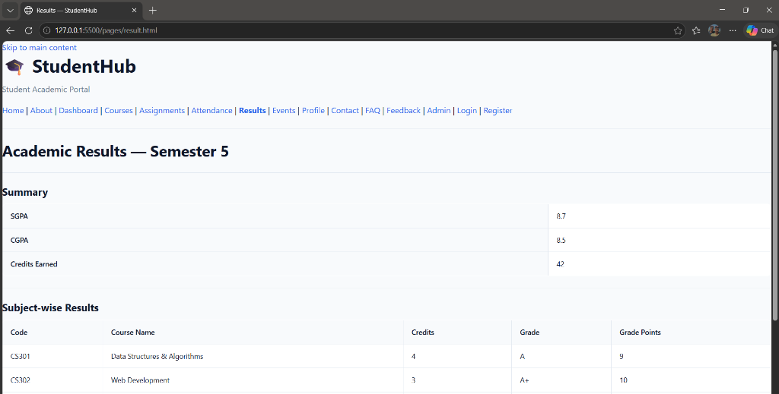

Rendered Output Screenshots (Desktop & Mobile):
💻 Desktop View (1280px) | 📱 Mobile View (412px)
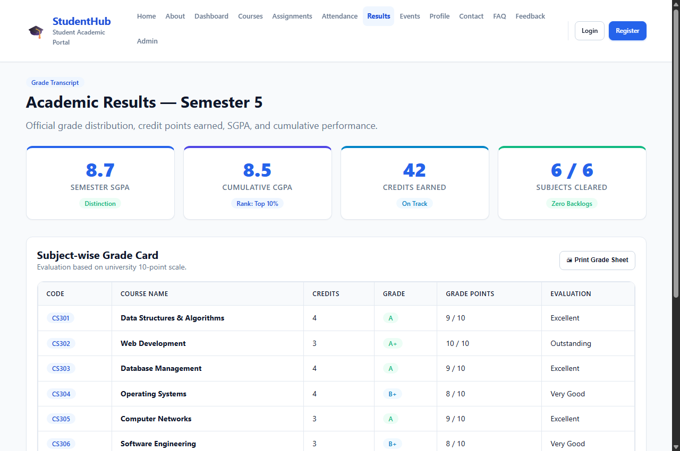 | 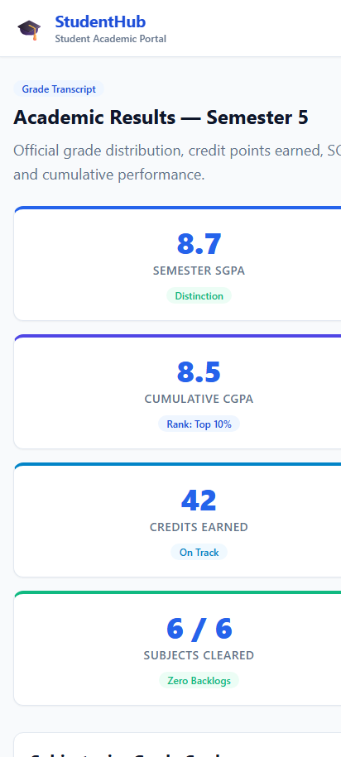

Complete Source Code:
<!DOCTYPE html>
<html lang="en">
<head>
<meta charset="UTF-8">
<meta name="viewport" content="width=device-width, initial-scale=1.0">
<meta name="description" content="StudentHub Results — View your academic results, grades, and SGPA for Semester 5.">
<title>Results — StudentHub</title>
<link rel="stylesheet" href="../css/style.css">
</head>
<body>

<a href="#main-content" class="skip-link">Skip to main content</a>

<!-- Site Header with Flexbox Navigation -->
<header class="site-header">
<div class="container header-inner">
<a href="../index.html" class="brand">
<span class="brand-icon" aria-hidden="true">&#127891;</span>
<div class="brand-text">
<h1>StudentHub</h1>
<p>Student Academic Portal</p>
</div>
</a>

<!-- Mobile Navigation Toggle -->
<button class="nav-toggle" aria-label="Toggle navigation menu" aria-expanded="false">
<span></span>
<span></span>
<span></span>
</button>

<!-- Navigation Links -->
<nav class="nav-menu" aria-label="Main navigation">
<ul class="nav-links">
<li><a href="../index.html" class="nav-link">Home</a></li>
<li><a href="about.html" class="nav-link">About</a></li>
<li><a href="dashboard.html" class="nav-link">Dashboard</a></li>
<li><a href="courses.html" class="nav-link">Courses</a></li>
<li><a href="assignment.html" class="nav-link">Assignments</a></li>
<li><a href="attendance.html" class="nav-link">Attendance</a></li>
<li><a href="result.html" class="nav-link active">Results</a></li>
<li><a href="events.html" class="nav-link">Events</a></li>
<li><a href="profile.html" class="nav-link">Profile</a></li>
<li><a href="contact.html" class="nav-link">Contact</a></li>
<li><a href="faq.html" class="nav-link">FAQ</a></li>
<li><a href="feedback.html" class="nav-link">Feedback</a></li>
<li><a href="admin.html" class="nav-link">Admin</a></li>
</ul>
<div class="nav-auth-buttons">
<a href="login.html" class="btn btn-outline btn-sm">Login</a>
<a href="register.html" class="btn btn-primary btn-sm">Register</a>
</div>
</nav>
</div>
</header>

<main id="main-content" class="site-main">
<div class="container">

<section class="section-title-wrap" aria-labelledby="results-heading">
<span class="badge badge-primary" style="margin-bottom: 0.5rem;">Grade Transcript</span>
<h2 id="results-heading">Academic Results &mdash; Semester 5</h2>
<p class="section-desc">Official grade distribution, credit points earned, SGPA, and cumulative performance.</p>
</section>

<!-- Results Summary Cards using CSS Grid -->
<div class="grid-stats" style="margin-bottom: var(--space-8);">
<div class="stat-card" style="border-top: 4px solid var(--color-primary);">
<span class="stat-number">8.7</span>
<span class="stat-label">Semester SGPA</span>
<span class="badge badge-success" style="margin-top: 0.5rem;">Distinction</span>
</div>
<div class="stat-card" style="border-top: 4px solid var(--color-secondary);">
<span class="stat-number">8.5</span>
<span class="stat-label">Cumulative CGPA</span>
<span class="badge badge-primary" style="margin-top: 0.5rem;">Rank: Top 10%</span>
</div>
<div class="stat-card" style="border-top: 4px solid var(--color-info);">
<span class="stat-number">42</span>
<span class="stat-label">Credits Earned</span>
<span class="badge badge-info" style="margin-top: 0.5rem;">On Track</span>
</div>
<div class="stat-card" style="border-top: 4px solid var(--color-success);">
<span class="stat-number">6 / 6</span>
<span class="stat-label">Subjects Cleared</span>
<span class="badge badge-success" style="margin-top: 0.5rem;">Zero Backlogs</span>
</div>
</div>

<!-- Subject-wise Results Table inside Card -->
<div class="card" style="margin-bottom: var(--space-8);">
<div class="card-header">
<div>
<h3 style="margin-bottom: 0; font-size: var(--font-size-lg);">Subject-wise Grade Card</h3>
<p style="font-size: var(--font-size-sm); color: var(--color-text-muted); margin-bottom: 0;">Evaluation based on university 10-point scale.</p>
</div>
<button class="btn btn-sm btn-outline">&#128424; Print Grade Sheet</button>
</div>

<div class="card-body">
<div class="table-responsive" style="margin-bottom: 0;">
<table class="data-table">
<thead>
<tr>
<th scope="col">Code</th>
<th scope="col">Course Name</th>
<th scope="col">Credits</th>
<th scope="col">Grade</th>
<th scope="col">Grade Points</th>
<th scope="col">Evaluation</th>
</tr>
</thead>
<tbody>
<tr>
<td><span class="badge badge-primary">CS301</span></td>
<td><strong>Data Structures &amp; Algorithms</strong></td>
<td>4</td>
<td><span class="badge badge-success">A</span></td>
<td>9 / 10</td>
<td>Excellent</td>
</tr>
<tr>
<td><span class="badge badge-primary">CS302</span></td>
<td><strong>Web Development</strong></td>
<td>3</td>
<td><span class="badge badge-success">A+</span></td>
<td>10 / 10</td>
<td>Outstanding</td>
</tr>
<tr>
<td><span class="badge badge-primary">CS303</span></td>
<td><strong>Database Management</strong></td>
<td>4</td>
<td><span class="badge badge-success">A</span></td>
<td>9 / 10</td>
<td>Excellent</td>
</tr>
<tr>
<td><span class="badge badge-primary">CS304</span></td>
<td><strong>Operating Systems</strong></td>
<td>4</td>
<td><span class="badge badge-info">B+</span></td>
<td>8 / 10</td>
<td>Very Good</td>
</tr>
<tr>
<td><span class="badge badge-primary">CS305</span></td>
<td><strong>Computer Networks</strong></td>
<td>3</td>
<td><span class="badge badge-success">A</span></td>
<td>9 / 10</td>
<td>Excellent</td>
</tr>
<tr>
<td><span class="badge badge-primary">CS306</span></td>
<td><strong>Software Engineering</strong></td>
<td>3</td>
<td><span class="badge badge-info">B+</span></td>
<td>8 / 10</td>
<td>Very Good</td>
</tr>
</tbody>
<tfoot>
<tr style="background-color: #f8fafc; font-weight: bold;">
<td colspan="4" style="text-align: right; padding-right: 1.5rem;">Semester SGPA:</td>
<td colspan="2"><span class="badge badge-primary" style="font-size: 0.95rem;">8.7 / 10</span></td>
</tr>
</tfoot>
</table>
</div>
</div>
</div>

</div>
</main>

<!-- Site Footer with Flexbox -->
<footer class="site-footer">
<div class="container footer-inner">
<div class="footer-top">
<div class="brand">
<span class="brand-icon" style="filter: brightness(1.2);">&#127891;</span>
<div class="brand-text">
<h2 style="color: #ffffff; font-size: 1.1rem; margin-bottom: 0;">StudentHub</h2>
<p style="color: #94a3b8; font-size: 0.75rem;">Student Academic Portal</p>
</div>
</div>
<ul class="footer-links">
<li><a href="../index.html">Home</a></li>
<li><a href="about.html">About</a></li>
<li><a href="dashboard.html">Dashboard</a></li>
<li><a href="courses.html">Courses</a></li>
<li><a href="events.html">Events</a></li>
<li><a href="contact.html">Contact</a></li>
<li><a href="faq.html">FAQ</a></li>
<li><a href="register.html">Register</a></li>
</ul>
</div>
<div class="footer-bottom">
<p>&copy; 2026 StudentHub. All rights reserved.</p>
<p>Designed with mobile-first CSS Grid &amp; Flexbox for accessibility and performance.</p>
</div>
</div>
</footer>

<script src="../js/main.js"></script>
</body>
</html>

3.10 Student Profile (pages/profile.html)
Description: Comprehensive student identity record containing personal address, phone, roll number, and department standings.
📌 CSS Grid & Flexbox Techniques
• CSS Grid: 2-column Personal Information Grid and 2-column Academic Information Grid.
• Flexbox: Profile banner with circular avatar ('RS'), student credentials, and action buttons.

Before vs After Transformation:
⚠️ Before Fix: Unstyled raw table stretching infinitely across the viewport:
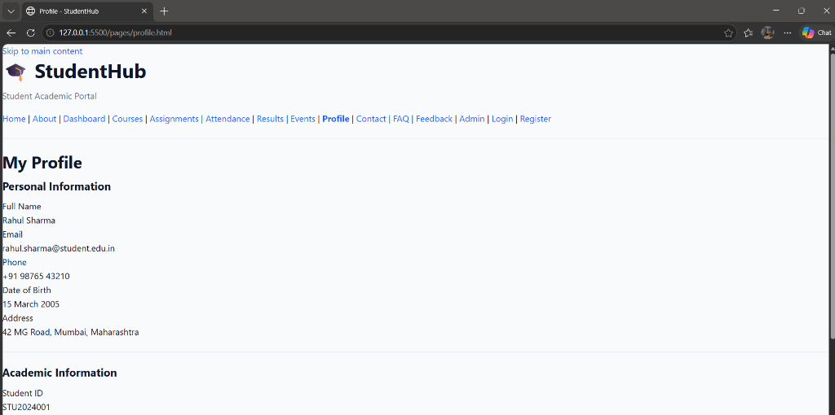

Rendered Output Screenshots (Desktop & Mobile):
💻 Desktop View (1280px) | 📱 Mobile View (412px)
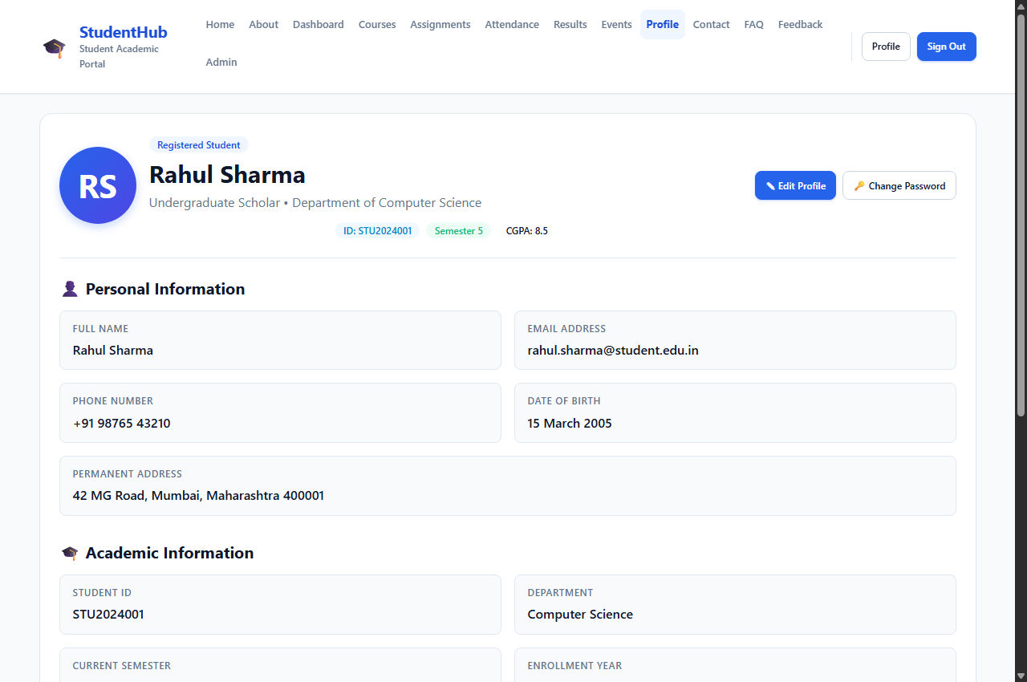 | 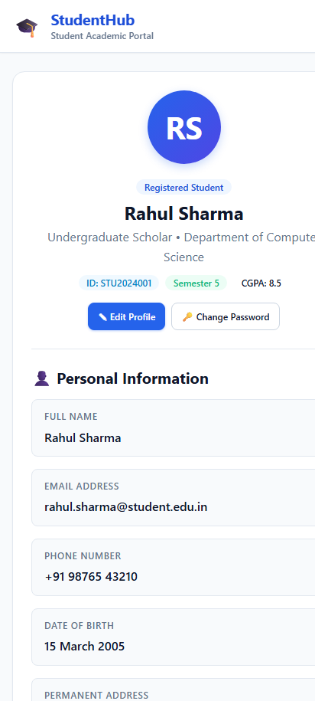

Complete Source Code:
<!DOCTYPE html>
<html lang="en">
<head>
<meta charset="UTF-8">
<meta name="viewport" content="width=device-width, initial-scale=1.0">
<meta name="description" content="StudentHub - Student Profile Page">
<title>Profile - StudentHub</title>
<link rel="stylesheet" href="../css/style.css">
</head>
<body>

<a href="#main-content" class="skip-link">Skip to main content</a>

<!-- Site Header with Flexbox Navigation -->
<header class="site-header">
<div class="container header-inner">
<a href="../index.html" class="brand">
<span class="brand-icon" aria-hidden="true">&#127891;</span>
<div class="brand-text">
<h1>StudentHub</h1>
<p>Student Academic Portal</p>
</div>
</a>

<!-- Mobile Navigation Toggle -->
<button class="nav-toggle" aria-label="Toggle navigation menu" aria-expanded="false">
<span></span>
<span></span>
<span></span>
</button>

<!-- Navigation Links -->
<nav class="nav-menu" aria-label="Main navigation">
<ul class="nav-links">
<li><a href="../index.html" class="nav-link">Home</a></li>
<li><a href="about.html" class="nav-link">About</a></li>
<li><a href="dashboard.html" class="nav-link">Dashboard</a></li>
<li><a href="courses.html" class="nav-link">Courses</a></li>
<li><a href="assignment.html" class="nav-link">Assignments</a></li>
<li><a href="attendance.html" class="nav-link">Attendance</a></li>
<li><a href="result.html" class="nav-link">Results</a></li>
<li><a href="events.html" class="nav-link">Events</a></li>
<li><a href="profile.html" class="nav-link active">Profile</a></li>
<li><a href="contact.html" class="nav-link">Contact</a></li>
<li><a href="faq.html" class="nav-link">FAQ</a></li>
<li><a href="feedback.html" class="nav-link">Feedback</a></li>
<li><a href="admin.html" class="nav-link">Admin</a></li>
</ul>
<div class="nav-auth-buttons">
<a href="profile.html" class="btn btn-outline btn-sm active">Profile</a>
<a href="login.html" class="btn btn-primary btn-sm">Sign Out</a>
</div>
</nav>
</div>
</header>

<main id="main-content" class="site-main">
<div class="container">

<!-- Profile Banner Card (Flexbox) -->
<div class="profile-card">
<div class="profile-header-banner">
<div class="profile-avatar-large" aria-hidden="true">RS</div>
<div style="flex: 1 1 auto;">
<span class="badge badge-primary" style="margin-bottom: 0.5rem;">Registered Student</span>
<h2 style="margin-bottom: 0.25rem;">Rahul Sharma</h2>
<p style="margin-bottom: 0.75rem; color: var(--color-text-muted);">
Undergraduate Scholar &bull; Department of Computer Science
</p>
<div style="display: flex; gap: 0.5rem; flex-wrap: wrap; justify-content: center;">
<span class="badge badge-info">ID: STU2024001</span>
<span class="badge badge-success">Semester 5</span>
<span class="badge badge-secondary">CGPA: 8.5</span>
</div>
</div>
<div style="display: flex; gap: 0.5rem; flex-wrap: wrap;">
<a href="#" class="btn btn-primary btn-sm">&#9998; Edit Profile</a>
<a href="#" class="btn btn-outline btn-sm">&#128273; Change Password</a>
</div>
</div>

<!-- Personal Information Grid (CSS Grid) -->
<div style="margin-bottom: var(--space-8);">
<div class="section-title-wrap" style="margin-bottom: var(--space-4);">
<h3 style="font-size: var(--font-size-lg);">&#128100; Personal Information</h3>
</div>

<dl class="profile-info-grid">
<div class="info-item">
<dt>Full Name</dt>
<dd>Rahul Sharma</dd>
</div>

<div class="info-item">
<dt>Email Address</dt>
<dd>rahul.sharma@student.edu.in</dd>
</div>

<div class="info-item">
<dt>Phone Number</dt>
<dd>+91 98765 43210</dd>
</div>

<div class="info-item">
<dt>Date of Birth</dt>
<dd>15 March 2005</dd>
</div>

<div class="info-item" style="grid-column: 1 / -1;">
<dt>Permanent Address</dt>
<dd>42 MG Road, Mumbai, Maharashtra 400001</dd>
</div>
</dl>
</div>

<!-- Academic Information Grid (CSS Grid) -->
<div>
<div class="section-title-wrap" style="margin-bottom: var(--space-4);">
<h3 style="font-size: var(--font-size-lg);">&#127891; Academic Information</h3>
</div>

<dl class="profile-info-grid">
<div class="info-item">
<dt>Student ID</dt>
<dd>STU2024001</dd>
</div>

<div class="info-item">
<dt>Department</dt>
<dd>Computer Science</dd>
</div>

<div class="info-item">
<dt>Current Semester</dt>
<dd>Semester 5 (Fall 2026)</dd>
</div>

<div class="info-item">
<dt>Enrollment Year</dt>
<dd>2024</dd>
</div>

<div class="info-item">
<dt>Current CGPA</dt>
<dd>8.5 / 10.0</dd>
</div>

<div class="info-item">
<dt>Academic Status</dt>
<dd><span class="badge badge-success">Good Standing</span></dd>
</div>
</dl>
</div>

<div class="card-footer" style="margin-top: var(--space-6);">
<a href="dashboard.html" class="btn btn-outline btn-sm">&larr; Return to Dashboard</a>
<a href="result.html" class="btn btn-sm btn-primary">View Full Grade Report &rarr;</a>
</div>
</div>

</div>
</main>

<!-- Site Footer with Flexbox -->
<footer class="site-footer">
<div class="container footer-inner">
<div class="footer-top">
<div class="brand">
<span class="brand-icon" style="filter: brightness(1.2);">&#127891;</span>
<div class="brand-text">
<h2 style="color: #ffffff; font-size: 1.1rem; margin-bottom: 0;">StudentHub</h2>
<p style="color: #94a3b8; font-size: 0.75rem;">Student Academic Portal</p>
</div>
</div>
<ul class="footer-links">
<li><a href="../index.html">Home</a></li>
<li><a href="about.html">About</a></li>
<li><a href="dashboard.html">Dashboard</a></li>
<li><a href="courses.html">Courses</a></li>
<li><a href="events.html">Events</a></li>
<li><a href="contact.html">Contact</a></li>
<li><a href="faq.html">FAQ</a></li>
<li><a href="register.html">Register</a></li>
</ul>
</div>
<div class="footer-bottom">
<p>&copy; 2026 StudentHub. All rights reserved.</p>
<p>Designed with mobile-first CSS Grid &amp; Flexbox for accessibility and performance.</p>
</div>
</div>
</footer>

<script src="../js/main.js"></script>
</body>
</html>

3.11 Login Authentication Page (pages/login.html)
Description: Secure student login interface with password recovery links and seamless redirect to dashboard.
📌 CSS Grid & Flexbox Techniques
• Flexbox: Centered authentication card, checkbox session remember row, and submission button.
• CSS: Focus rings and input field states.

Rendered Output Screenshots (Desktop & Mobile):
💻 Desktop View (1280px) | 📱 Mobile View (412px)
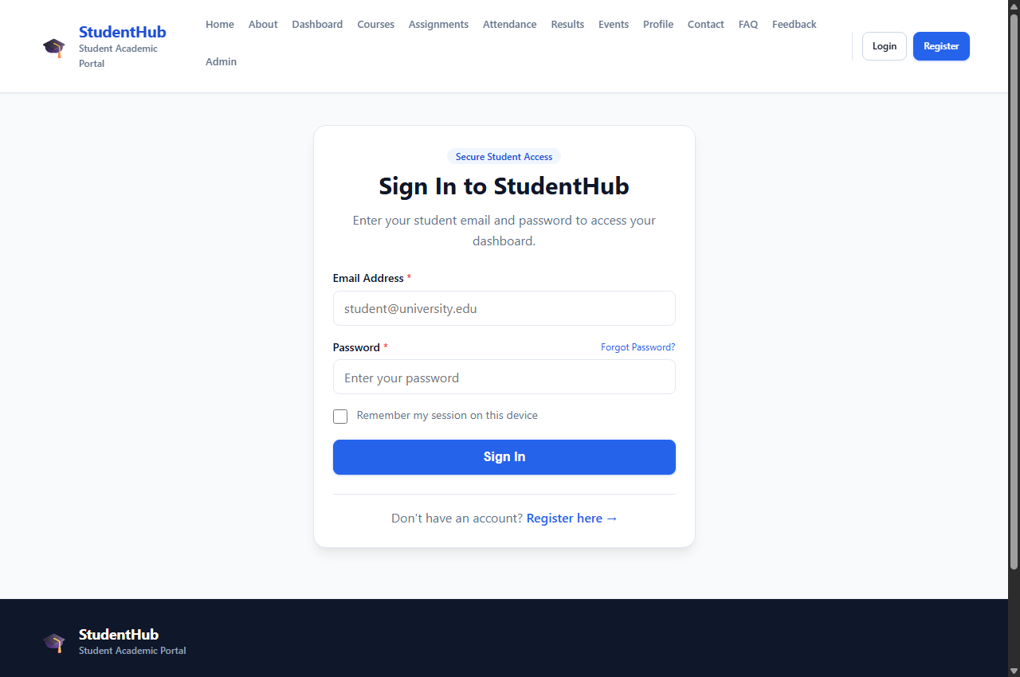 | 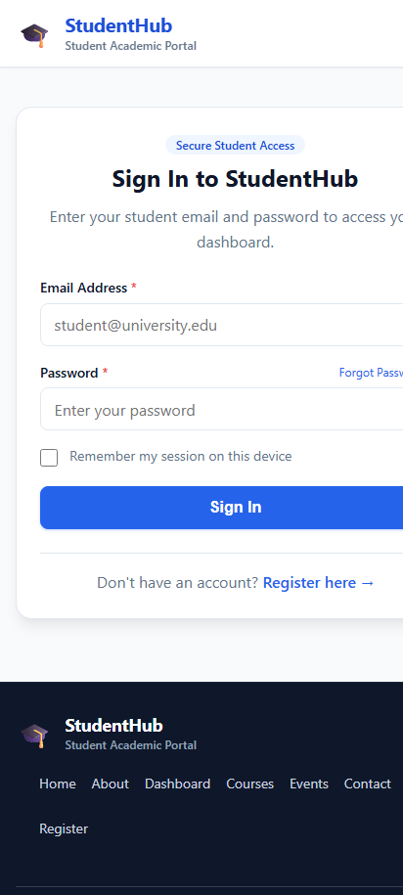

Complete Source Code:
<!DOCTYPE html>
<html lang="en">
<head>
<meta charset="UTF-8">
<meta name="viewport" content="width=device-width, initial-scale=1.0">
<meta name="description" content="Login to your StudentHub account to access your academic portal.">
<title>Login - StudentHub</title>
<link rel="stylesheet" href="../css/style.css">
</head>
<body>

<a href="#main-content" class="skip-link">Skip to main content</a>

<!-- Site Header with Flexbox Navigation -->
<header class="site-header">
<div class="container header-inner">
<a href="../index.html" class="brand">
<span class="brand-icon" aria-hidden="true">&#127891;</span>
<div class="brand-text">
<h1>StudentHub</h1>
<p>Student Academic Portal</p>
</div>
</a>

<!-- Mobile Navigation Toggle -->
<button class="nav-toggle" aria-label="Toggle navigation menu" aria-expanded="false">
<span></span>
<span></span>
<span></span>
</button>

<!-- Navigation Links -->
<nav class="nav-menu" aria-label="Main navigation">
<ul class="nav-links">
<li><a href="../index.html" class="nav-link">Home</a></li>
<li><a href="about.html" class="nav-link">About</a></li>
<li><a href="dashboard.html" class="nav-link">Dashboard</a></li>
<li><a href="courses.html" class="nav-link">Courses</a></li>
<li><a href="assignment.html" class="nav-link">Assignments</a></li>
<li><a href="attendance.html" class="nav-link">Attendance</a></li>
<li><a href="result.html" class="nav-link">Results</a></li>
<li><a href="events.html" class="nav-link">Events</a></li>
<li><a href="profile.html" class="nav-link">Profile</a></li>
<li><a href="contact.html" class="nav-link">Contact</a></li>
<li><a href="faq.html" class="nav-link">FAQ</a></li>
<li><a href="feedback.html" class="nav-link">Feedback</a></li>
<li><a href="admin.html" class="nav-link">Admin</a></li>
</ul>
<div class="nav-auth-buttons">
<a href="login.html" class="btn btn-outline btn-sm active">Login</a>
<a href="register.html" class="btn btn-primary btn-sm">Register</a>
</div>
</nav>
</div>
</header>

<main id="main-content" class="site-main">
<div class="container">
<div class="auth-wrapper">
<div class="auth-card" style="max-width: 480px;">
<div class="auth-header">
<span class="badge badge-primary" style="margin-bottom: 0.5rem;">Secure Student Access</span>
<h2>Sign In to StudentHub</h2>
<p style="margin-bottom: 0;">Enter your student email and password to access your dashboard.</p>
</div>

<form action="dashboard.html" method="get">
<div class="form-group" style="margin-bottom: var(--space-4);">
<label for="email" class="form-label">Email Address <span style="color: var(--color-danger)">*</span></label>
<input type="email" id="email" name="email" class="form-control" placeholder="student@university.edu" required autocomplete="email">
</div>

<div class="form-group" style="margin-bottom: var(--space-4);">
<div style="display: flex; justify-content: space-between; align-items: center;">
<label for="password" class="form-label">Password <span style="color: var(--color-danger)">*</span></label>
<a href="contact.html" style="font-size: var(--font-size-xs);">Forgot Password?</a>
</div>
<input type="password" id="password" name="password" class="form-control" placeholder="Enter your password" required autocomplete="current-password">
</div>

<div class="checkbox-group" style="margin-bottom: var(--space-5);">
<input type="checkbox" id="remember" name="remember">
<label for="remember" class="checkbox-label">Remember my session on this device</label>
</div>

<button type="submit" class="btn btn-primary btn-block" style="font-size: 1rem;">Sign In</button>
</form>

<div style="text-align: center; margin-top: var(--space-6); padding-top: var(--space-4); border-top: 1px solid var(--color-border);">
<p style="margin-bottom: 0;">Don't have an account? <a href="register.html" style="font-weight: 600;">Register here &rarr;</a></p>
</div>
</div>
</div>
</div>
</main>

<!-- Site Footer with Flexbox -->
<footer class="site-footer">
<div class="container footer-inner">
<div class="footer-top">
<div class="brand">
<span class="brand-icon" style="filter: brightness(1.2);">&#127891;</span>
<div class="brand-text">
<h2 style="color: #ffffff; font-size: 1.1rem; margin-bottom: 0;">StudentHub</h2>
<p style="color: #94a3b8; font-size: 0.75rem;">Student Academic Portal</p>
</div>
</div>
<ul class="footer-links">
<li><a href="../index.html">Home</a></li>
<li><a href="about.html">About</a></li>
<li><a href="dashboard.html">Dashboard</a></li>
<li><a href="courses.html">Courses</a></li>
<li><a href="events.html">Events</a></li>
<li><a href="contact.html">Contact</a></li>
<li><a href="faq.html">FAQ</a></li>
<li><a href="register.html">Register</a></li>
</ul>
</div>
<div class="footer-bottom">
<p>&copy; 2026 StudentHub. All rights reserved.</p>
<p>Designed with mobile-first CSS Grid &amp; Flexbox for accessibility and performance.</p>
</div>
</div>
</footer>

<script src="../js/main.js"></script>
</body>
</html>

3.12 Contact & Support Desk (pages/contact.html)
Description: Student help desk portal with department inquiry selector and campus location address.
📌 CSS Grid & Flexbox Techniques
• CSS Grid: 2-column desktop layout (Send Message form on left, Campus Office address on right).
• Flexbox: Form header and submit CTA.

Rendered Output Screenshots (Desktop & Mobile):
💻 Desktop View (1280px) | 📱 Mobile View (412px)
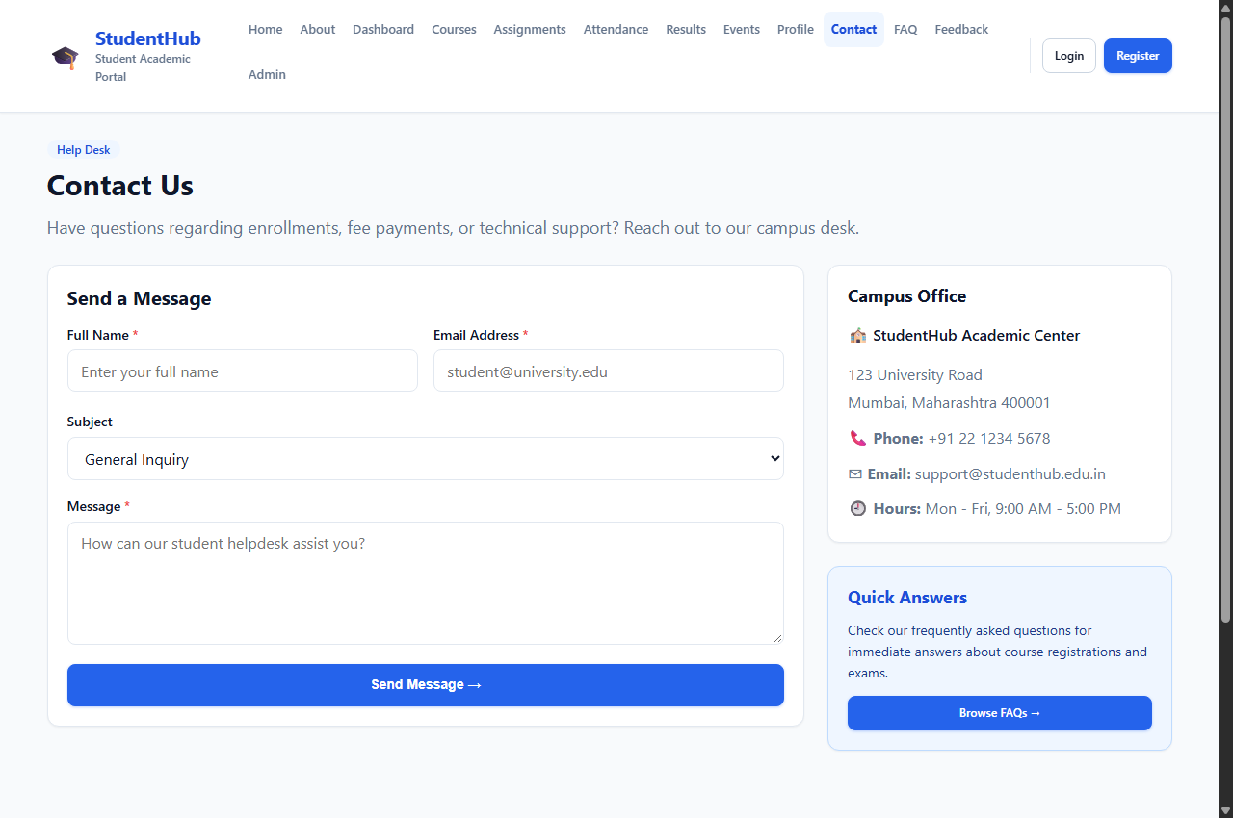 | 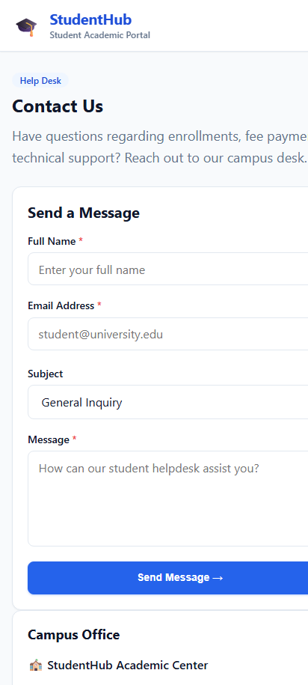

Complete Source Code:
<!DOCTYPE html>
<html lang="en">
<head>
<meta charset="UTF-8">
<meta name="viewport" content="width=device-width, initial-scale=1.0">
<meta name="description" content="StudentHub - Contact Support and Administration">
<title>Contact - StudentHub</title>
<link rel="stylesheet" href="../css/style.css">
</head>
<body>

<a href="#main-content" class="skip-link">Skip to main content</a>

<!-- Site Header with Flexbox Navigation -->
<header class="site-header">
<div class="container header-inner">
<a href="../index.html" class="brand">
<span class="brand-icon" aria-hidden="true">&#127891;</span>
<div class="brand-text">
<h1>StudentHub</h1>
<p>Student Academic Portal</p>
</div>
</a>

<!-- Mobile Navigation Toggle -->
<button class="nav-toggle" aria-label="Toggle navigation menu" aria-expanded="false">
<span></span>
<span></span>
<span></span>
</button>

<!-- Navigation Links -->
<nav class="nav-menu" aria-label="Main navigation">
<ul class="nav-links">
<li><a href="../index.html" class="nav-link">Home</a></li>
<li><a href="about.html" class="nav-link">About</a></li>
<li><a href="dashboard.html" class="nav-link">Dashboard</a></li>
<li><a href="courses.html" class="nav-link">Courses</a></li>
<li><a href="assignment.html" class="nav-link">Assignments</a></li>
<li><a href="attendance.html" class="nav-link">Attendance</a></li>
<li><a href="result.html" class="nav-link">Results</a></li>
<li><a href="events.html" class="nav-link">Events</a></li>
<li><a href="profile.html" class="nav-link">Profile</a></li>
<li><a href="contact.html" class="nav-link active">Contact</a></li>
<li><a href="faq.html" class="nav-link">FAQ</a></li>
<li><a href="feedback.html" class="nav-link">Feedback</a></li>
<li><a href="admin.html" class="nav-link">Admin</a></li>
</ul>
<div class="nav-auth-buttons">
<a href="login.html" class="btn btn-outline btn-sm">Login</a>
<a href="register.html" class="btn btn-primary btn-sm">Register</a>
</div>
</nav>
</div>
</header>

<main id="main-content" class="site-main">
<div class="container">

<section class="section-title-wrap" aria-labelledby="contact-heading">
<span class="badge badge-primary" style="margin-bottom: 0.5rem;">Help Desk</span>
<h2 id="contact-heading">Contact Us</h2>
<p class="section-desc">Have questions regarding enrollments, fee payments, or technical support? Reach out to our campus desk.</p>
</section>

<!-- 2-Column Responsive Layout using CSS Grid -->
<div class="dashboard-layout" style="margin-bottom: var(--space-8);">

<!-- Contact Form Card -->
<div class="card">
<div class="card-header">
<h3 style="margin-bottom: 0; font-size: var(--font-size-lg);">Send a Message</h3>
</div>
<div class="card-body">
<form action="#" method="post">
<div class="form-grid form-grid-2">
<div class="form-group">
<label for="name" class="form-label">Full Name <span style="color: var(--color-danger)">*</span></label>
<input type="text" id="name" name="name" class="form-control" placeholder="Enter your full name" required>
</div>

<div class="form-group">
<label for="email" class="form-label">Email Address <span style="color: var(--color-danger)">*</span></label>
<input type="email" id="email" name="email" class="form-control" placeholder="student@university.edu" required>
</div>
</div>

<div class="form-group" style="margin-bottom: var(--space-4);">
<label for="subject" class="form-label">Subject</label>
<select id="subject" name="subject" class="form-control">
<option value="general">General Inquiry</option>
<option value="technical">Technical Support</option>
<option value="feedback">Feedback</option>
<option value="complaint">Complaint</option>
</select>
</div>

<div class="form-group" style="margin-bottom: var(--space-5);">
<label for="message" class="form-label">Message <span style="color: var(--color-danger)">*</span></label>
<textarea id="message" name="message" class="form-control" required rows="5" placeholder="How can our student helpdesk assist you?"></textarea>
</div>

<button type="submit" class="btn btn-primary btn-block">Send Message &rarr;</button>
</form>
</div>
</div>

<!-- Office Information Card -->
<aside style="display: flex; flex-direction: column; gap: var(--space-6);">
<div class="card">
<div class="card-header">
<h3 style="margin-bottom: 0; font-size: var(--font-size-md);">Campus Office</h3>
</div>
<div class="card-body">
<address style="font-style: normal; line-height: 1.8; color: var(--color-text-muted);">
<p style="margin-bottom: var(--space-3); font-weight: 600; color: var(--color-text-main);">
&#127979; StudentHub Academic Center
</p>
<p style="margin-bottom: var(--space-2);">
123 University Road<br>
Mumbai, Maharashtra 400001
</p>
<p style="margin-bottom: var(--space-2);">
&#128222; <strong>Phone:</strong> +91 22 1234 5678
</p>
<p style="margin-bottom: var(--space-2);">
&#9993; <strong>Email:</strong> support@studenthub.edu.in
</p>
<p style="margin-bottom: 0;">
&#128344; <strong>Hours:</strong> Mon - Fri, 9:00 AM - 5:00 PM
</p>
</address>
</div>
</div>

<div class="card" style="background-color: var(--color-primary-light); border-color: #bfdbfe;">
<h4 style="color: var(--color-primary-dark); font-size: var(--font-size-md);">Quick Answers</h4>
<p style="font-size: var(--font-size-sm); color: #1e3a8a; margin-bottom: var(--space-3);">
Check our frequently asked questions for immediate answers about course registrations and exams.
</p>
<a href="faq.html" class="btn btn-sm btn-primary">Browse FAQs &rarr;</a>
</div>
</aside>

</div>

</div>
</main>

<!-- Site Footer with Flexbox -->
<footer class="site-footer">
<div class="container footer-inner">
<div class="footer-top">
<div class="brand">
<span class="brand-icon" style="filter: brightness(1.2);">&#127891;</span>
<div class="brand-text">
<h2 style="color: #ffffff; font-size: 1.1rem; margin-bottom: 0;">StudentHub</h2>
<p style="color: #94a3b8; font-size: 0.75rem;">Student Academic Portal</p>
</div>
</div>
<ul class="footer-links">
<li><a href="../index.html">Home</a></li>
<li><a href="about.html">About</a></li>
<li><a href="dashboard.html">Dashboard</a></li>
<li><a href="courses.html">Courses</a></li>
<li><a href="events.html">Events</a></li>
<li><a href="contact.html">Contact</a></li>
<li><a href="faq.html">FAQ</a></li>
<li><a href="register.html">Register</a></li>
</ul>
</div>
<div class="footer-bottom">
<p>&copy; 2026 StudentHub. All rights reserved.</p>
<p>Designed with mobile-first CSS Grid &amp; Flexbox for accessibility and performance.</p>
</div>
</div>
</footer>

<script src="../js/main.js"></script>
</body>
</html>

3.13 Frequently Asked Questions (FAQ) (pages/faq.html)
Description: Campus knowledgebase answering questions regarding course drops, exams, and attendance rules.
📌 CSS Grid & Flexbox Techniques
• Flexbox: Accordion <details>/<summary> interactive widgets with animated toggle indicators (+/-).
• CSS Grid: Support card banner.

Rendered Output Screenshots (Desktop & Mobile):
💻 Desktop View (1280px) | 📱 Mobile View (412px)
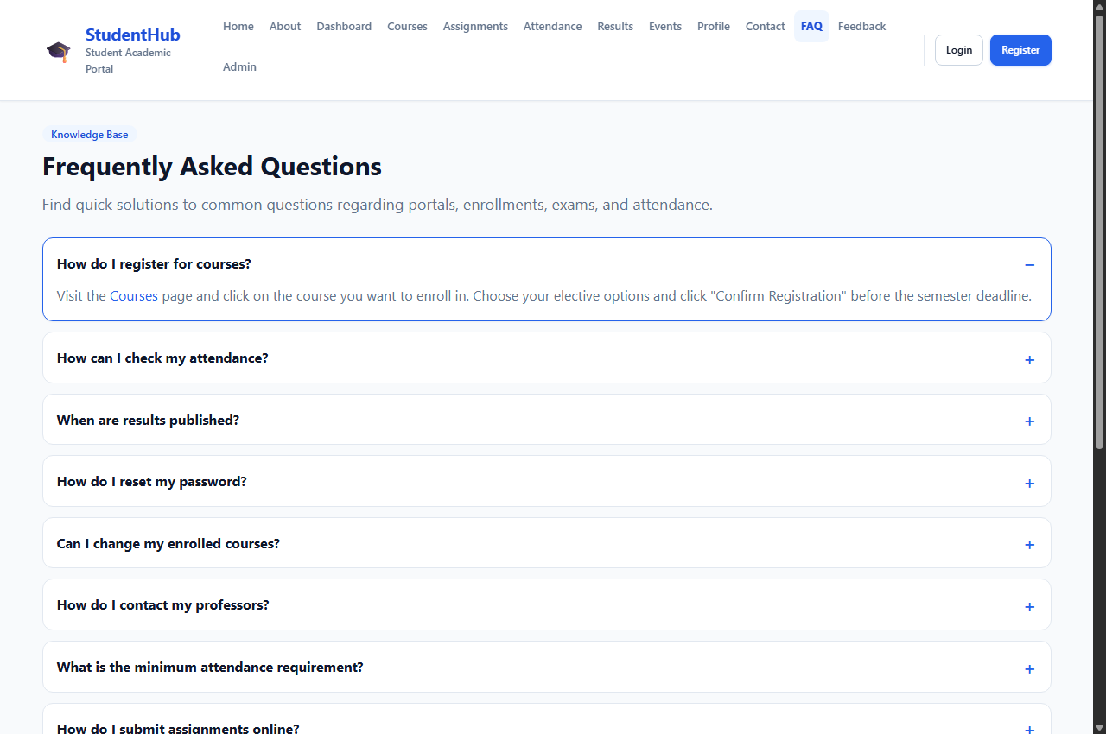 | 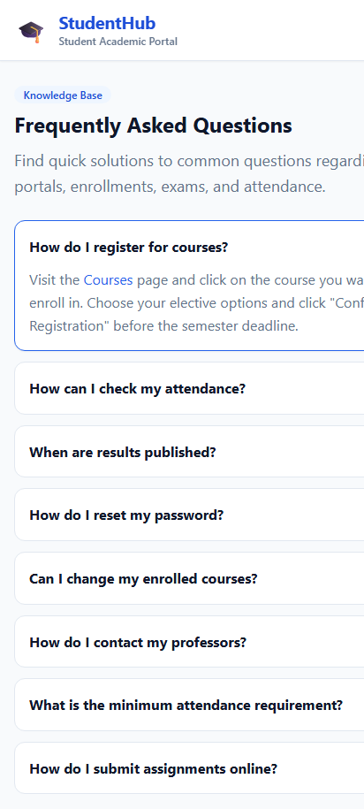

Complete Source Code:
<!DOCTYPE html>
<html lang="en">
<head>
<meta charset="UTF-8">
<meta name="viewport" content="width=device-width, initial-scale=1.0">
<meta name="description" content="StudentHub - Frequently Asked Questions">
<title>FAQ - StudentHub</title>
<link rel="stylesheet" href="../css/style.css">
</head>
<body>

<a href="#main-content" class="skip-link">Skip to main content</a>

<!-- Site Header with Flexbox Navigation -->
<header class="site-header">
<div class="container header-inner">
<a href="../index.html" class="brand">
<span class="brand-icon" aria-hidden="true">&#127891;</span>
<div class="brand-text">
<h1>StudentHub</h1>
<p>Student Academic Portal</p>
</div>
</a>

<!-- Mobile Navigation Toggle -->
<button class="nav-toggle" aria-label="Toggle navigation menu" aria-expanded="false">
<span></span>
<span></span>
<span></span>
</button>

<!-- Navigation Links -->
<nav class="nav-menu" aria-label="Main navigation">
<ul class="nav-links">
<li><a href="../index.html" class="nav-link">Home</a></li>
<li><a href="about.html" class="nav-link">About</a></li>
<li><a href="dashboard.html" class="nav-link">Dashboard</a></li>
<li><a href="courses.html" class="nav-link">Courses</a></li>
<li><a href="assignment.html" class="nav-link">Assignments</a></li>
<li><a href="attendance.html" class="nav-link">Attendance</a></li>
<li><a href="result.html" class="nav-link">Results</a></li>
<li><a href="events.html" class="nav-link">Events</a></li>
<li><a href="profile.html" class="nav-link">Profile</a></li>
<li><a href="contact.html" class="nav-link">Contact</a></li>
<li><a href="faq.html" class="nav-link active">FAQ</a></li>
<li><a href="feedback.html" class="nav-link">Feedback</a></li>
<li><a href="admin.html" class="nav-link">Admin</a></li>
</ul>
<div class="nav-auth-buttons">
<a href="login.html" class="btn btn-outline btn-sm">Login</a>
<a href="register.html" class="btn btn-primary btn-sm">Register</a>
</div>
</nav>
</div>
</header>

<main id="main-content" class="site-main">
<div class="container">

<section class="section-title-wrap" aria-labelledby="faq-heading">
<span class="badge badge-primary" style="margin-bottom: 0.5rem;">Knowledge Base</span>
<h2 id="faq-heading">Frequently Asked Questions</h2>
<p class="section-desc">Find quick solutions to common questions regarding portals, enrollments, exams, and attendance.</p>
</section>

<!-- FAQ Accordion List -->
<div class="faq-list">
<details class="faq-item" open>
<summary>How do I register for courses?</summary>
<p>Visit the <a href="courses.html">Courses</a> page and click on the course you want to enroll in. Choose your elective options and click "Confirm Registration" before the semester deadline.</p>
</details>

<details class="faq-item">
<summary>How can I check my attendance?</summary>
<p>Go to the <a href="attendance.html">Attendance</a> page from your dashboard to view course-wise attendance percentage and overall lectures attended.</p>
</details>

<details class="faq-item">
<summary>When are results published?</summary>
<p>Results are typically published within 2 weeks after the examination period ends. You can check subject-wise grade sheets on the <a href="result.html">Results</a> page.</p>
</details>

<details class="faq-item">
<summary>How do I reset my password?</summary>
<p>Contact the admin office at <a href="contact.html">support@studenthub.edu.in</a> or use the password recovery link on the <a href="login.html">Login</a> page.</p>
</details>

<details class="faq-item">
<summary>Can I change my enrolled courses?</summary>
<p>Yes, course changes and elective modifications are allowed within the first 2 weeks of the semester through your academic counselor.</p>
</details>

<details class="faq-item">
<summary>How do I contact my professors?</summary>
<p>Visit the <a href="courses.html">Courses</a> page to find faculty email addresses and department office cabin numbers.</p>
</details>

<details class="faq-item">
<summary>What is the minimum attendance requirement?</summary>
<p>A minimum of <strong>75% attendance</strong> is strictly required in each subject to be eligible for end-semester examinations.</p>
</details>

<details class="faq-item">
<summary>How do I submit assignments online?</summary>
<p>Navigate to the <a href="assignment.html">Assignments</a> page, locate the pending assignment task, and click "Upload" to attach your files.</p>
</details>
</div>

<!-- Still Have Questions Card -->
<div class="card" style="text-align: center; background: linear-gradient(135deg, #eff6ff 0%, #e0e7ff 100%); border-color: #bfdbfe;">
<h3 style="margin-bottom: var(--space-2); color: var(--color-primary-dark);">Still have questions?</h3>
<p style="margin-bottom: var(--space-4); max-width: 600px; margin-left: auto; margin-right: auto;">
Can't find the answer you're looking for? Reach out to our campus student support center and our team will assist you.
</p>
<div>
<a href="contact.html" class="btn btn-primary">&#9993; Contact Support Team</a>
</div>
</div>

</div>
</main>

<!-- Site Footer with Flexbox -->
<footer class="site-footer">
<div class="container footer-inner">
<div class="footer-top">
<div class="brand">
<span class="brand-icon" style="filter: brightness(1.2);">&#127891;</span>
<div class="brand-text">
<h2 style="color: #ffffff; font-size: 1.1rem; margin-bottom: 0;">StudentHub</h2>
<p style="color: #94a3b8; font-size: 0.75rem;">Student Academic Portal</p>
</div>
</div>
<ul class="footer-links">
<li><a href="../index.html">Home</a></li>
<li><a href="about.html">About</a></li>
<li><a href="dashboard.html">Dashboard</a></li>
<li><a href="courses.html">Courses</a></li>
<li><a href="events.html">Events</a></li>
<li><a href="contact.html">Contact</a></li>
<li><a href="faq.html">FAQ</a></li>
<li><a href="register.html">Register</a></li>
</ul>
</div>
<div class="footer-bottom">
<p>&copy; 2026 StudentHub. All rights reserved.</p>
<p>Designed with mobile-first CSS Grid &amp; Flexbox for accessibility and performance.</p>
</div>
</div>
</footer>

<script src="../js/main.js"></script>
</body>
</html>

3.14 Feedback & Experience Form (pages/feedback.html)
Description: Interactive rating and suggestion form for student portal improvements.
📌 CSS Grid & Flexbox Techniques
• CSS Grid: 2-column inputs for name and email.
• Flexbox: Radio rating pills (1 to 5 stars) and centered submission wrapper.

Rendered Output Screenshots (Desktop & Mobile):
💻 Desktop View (1280px) | 📱 Mobile View (412px)
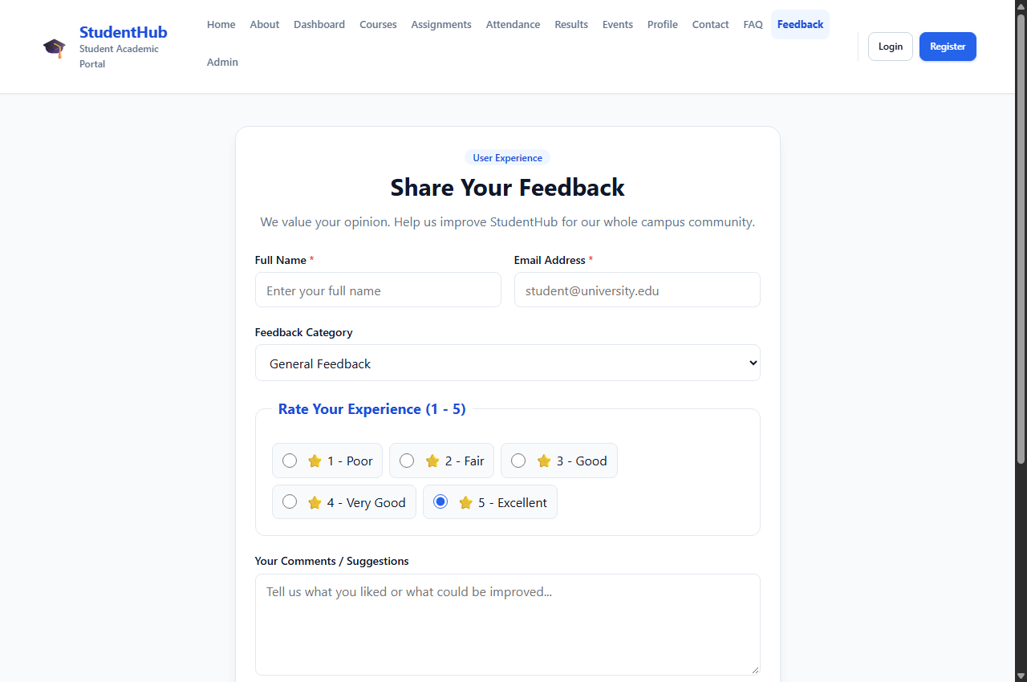 | 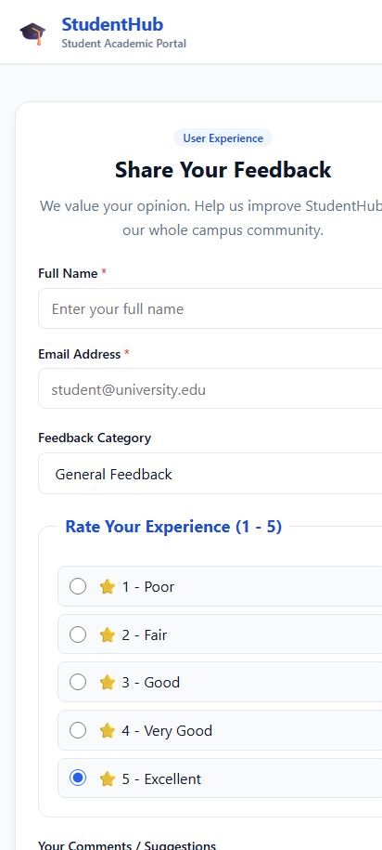

Complete Source Code:
<!DOCTYPE html>
<html lang="en">
<head>
<meta charset="UTF-8">
<meta name="viewport" content="width=device-width, initial-scale=1.0">
<meta name="description" content="StudentHub - Share Your Feedback">
<title>Feedback - StudentHub</title>
<link rel="stylesheet" href="../css/style.css">
</head>
<body>

<a href="#main-content" class="skip-link">Skip to main content</a>

<!-- Site Header with Flexbox Navigation -->
<header class="site-header">
<div class="container header-inner">
<a href="../index.html" class="brand">
<span class="brand-icon" aria-hidden="true">&#127891;</span>
<div class="brand-text">
<h1>StudentHub</h1>
<p>Student Academic Portal</p>
</div>
</a>

<!-- Mobile Navigation Toggle -->
<button class="nav-toggle" aria-label="Toggle navigation menu" aria-expanded="false">
<span></span>
<span></span>
<span></span>
</button>

<!-- Navigation Links -->
<nav class="nav-menu" aria-label="Main navigation">
<ul class="nav-links">
<li><a href="../index.html" class="nav-link">Home</a></li>
<li><a href="about.html" class="nav-link">About</a></li>
<li><a href="dashboard.html" class="nav-link">Dashboard</a></li>
<li><a href="courses.html" class="nav-link">Courses</a></li>
<li><a href="assignment.html" class="nav-link">Assignments</a></li>
<li><a href="attendance.html" class="nav-link">Attendance</a></li>
<li><a href="result.html" class="nav-link">Results</a></li>
<li><a href="events.html" class="nav-link">Events</a></li>
<li><a href="profile.html" class="nav-link">Profile</a></li>
<li><a href="contact.html" class="nav-link">Contact</a></li>
<li><a href="faq.html" class="nav-link">FAQ</a></li>
<li><a href="feedback.html" class="nav-link active">Feedback</a></li>
<li><a href="admin.html" class="nav-link">Admin</a></li>
</ul>
<div class="nav-auth-buttons">
<a href="login.html" class="btn btn-outline btn-sm">Login</a>
<a href="register.html" class="btn btn-primary btn-sm">Register</a>
</div>
</nav>
</div>
</header>

<main id="main-content" class="site-main">
<div class="container">
<div class="auth-wrapper">
<div class="auth-card" style="max-width: 680px;">
<div class="auth-header">
<span class="badge badge-primary" style="margin-bottom: 0.5rem;">User Experience</span>
<h2>Share Your Feedback</h2>
<p style="margin-bottom: 0;">We value your opinion. Help us improve StudentHub for our whole campus community.</p>
</div>

<form action="#" method="post">
<div class="form-grid form-grid-2">
<div class="form-group">
<label for="name" class="form-label">Full Name <span style="color: var(--color-danger)">*</span></label>
<input type="text" id="name" name="name" class="form-control" placeholder="Enter your full name" required>
</div>

<div class="form-group">
<label for="email" class="form-label">Email Address <span style="color: var(--color-danger)">*</span></label>
<input type="email" id="email" name="email" class="form-control" placeholder="student@university.edu" required>
</div>
</div>

<div class="form-group" style="margin-bottom: var(--space-5);">
<label for="type" class="form-label">Feedback Category</label>
<select id="type" name="type" class="form-control">
<option value="general">General Feedback</option>
<option value="bug">Bug Report / Glitch</option>
<option value="feature">Feature Request</option>
<option value="complaint">Academic Complaint</option>
<option value="suggestion">Portal Suggestion</option>
</select>
</div>

<fieldset class="form-fieldset">
<legend class="form-legend">Rate Your Experience (1 - 5)</legend>
<div class="rating-options">
<label class="rating-option" for="rating1">
<input type="radio" id="rating1" name="rating" value="1">
<span>&#11088; 1 - Poor</span>
</label>

<label class="rating-option" for="rating2">
<input type="radio" id="rating2" name="rating" value="2">
<span>&#11088; 2 - Fair</span>
</label>

<label class="rating-option" for="rating3">
<input type="radio" id="rating3" name="rating" value="3">
<span>&#11088; 3 - Good</span>
</label>

<label class="rating-option" for="rating4">
<input type="radio" id="rating4" name="rating" value="4">
<span>&#11088; 4 - Very Good</span>
</label>

<label class="rating-option" for="rating5">
<input type="radio" id="rating5" name="rating" value="5" checked>
<span>&#11088; 5 - Excellent</span>
</label>
</div>
</fieldset>

<div class="form-group" style="margin-bottom: var(--space-5);">
<label for="message" class="form-label">Your Comments / Suggestions</label>
<textarea id="message" name="message" class="form-control" rows="5" placeholder="Tell us what you liked or what could be improved..."></textarea>
</div>

<button type="submit" class="btn btn-primary btn-block" style="font-size: 1rem;">Submit Feedback</button>
</form>
</div>
</div>
</div>
</main>

<!-- Site Footer with Flexbox -->
<footer class="site-footer">
<div class="container footer-inner">
<div class="footer-top">
<div class="brand">
<span class="brand-icon" style="filter: brightness(1.2);">&#127891;</span>
<div class="brand-text">
<h2 style="color: #ffffff; font-size: 1.1rem; margin-bottom: 0;">StudentHub</h2>
<p style="color: #94a3b8; font-size: 0.75rem;">Student Academic Portal</p>
</div>
</div>
<ul class="footer-links">
<li><a href="../index.html">Home</a></li>
<li><a href="about.html">About</a></li>
<li><a href="dashboard.html">Dashboard</a></li>
<li><a href="courses.html">Courses</a></li>
<li><a href="events.html">Events</a></li>
<li><a href="contact.html">Contact</a></li>
<li><a href="faq.html">FAQ</a></li>
<li><a href="register.html">Register</a></li>
</ul>
</div>
<div class="footer-bottom">
<p>&copy; 2026 StudentHub. All rights reserved.</p>
<p>Designed with mobile-first CSS Grid &amp; Flexbox for accessibility and performance.</p>
</div>
</div>
</footer>

<script src="../js/main.js"></script>
</body>
</html>

3.15 University Admin Panel (pages/admin.html)
Description: Campus administrative management portal for reviewing student registrations and course capacities.
📌 CSS Grid & Flexbox Techniques
• CSS Grid: 4 platform telemetry counters (10,248 students, 542 courses, 28 pending, 99.8% uptime) + 3-col quick admin actions.
• Flexbox: Approval/Rejection action pills and table controls.

Rendered Output Screenshots (Desktop & Mobile):
💻 Desktop View (1280px) | 📱 Mobile View (412px)
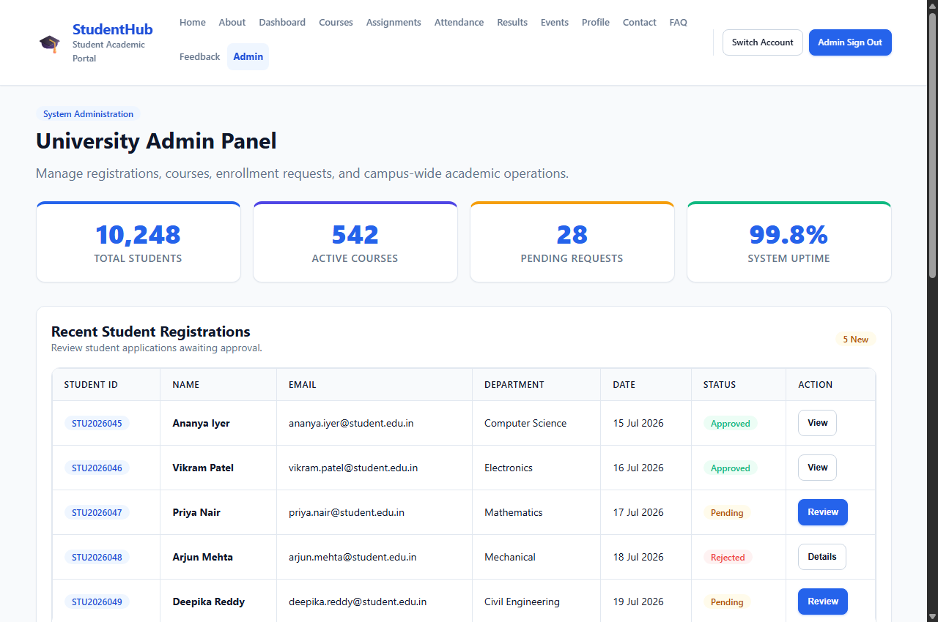 | 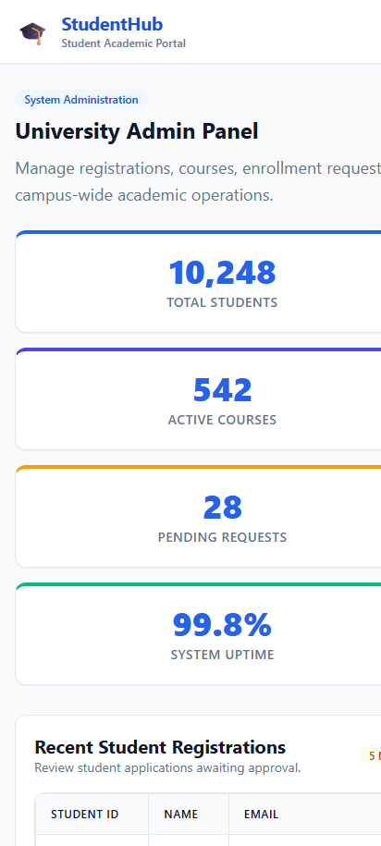

Complete Source Code:
<!DOCTYPE html>
<html lang="en">
<head>
<meta charset="UTF-8">
<meta name="viewport" content="width=device-width, initial-scale=1.0">
<meta name="description" content="StudentHub - Admin Panel">
<title>Admin Panel - StudentHub</title>
<link rel="stylesheet" href="../css/style.css">
</head>
<body>

<a href="#main-content" class="skip-link">Skip to main content</a>

<!-- Site Header with Flexbox Navigation -->
<header class="site-header">
<div class="container header-inner">
<a href="../index.html" class="brand">
<span class="brand-icon" aria-hidden="true">&#127891;</span>
<div class="brand-text">
<h1>StudentHub</h1>
<p>Student Academic Portal</p>
</div>
</a>

<!-- Mobile Navigation Toggle -->
<button class="nav-toggle" aria-label="Toggle navigation menu" aria-expanded="false">
<span></span>
<span></span>
<span></span>
</button>

<!-- Navigation Links -->
<nav class="nav-menu" aria-label="Main navigation">
<ul class="nav-links">
<li><a href="../index.html" class="nav-link">Home</a></li>
<li><a href="about.html" class="nav-link">About</a></li>
<li><a href="dashboard.html" class="nav-link">Dashboard</a></li>
<li><a href="courses.html" class="nav-link">Courses</a></li>
<li><a href="assignment.html" class="nav-link">Assignments</a></li>
<li><a href="attendance.html" class="nav-link">Attendance</a></li>
<li><a href="result.html" class="nav-link">Results</a></li>
<li><a href="events.html" class="nav-link">Events</a></li>
<li><a href="profile.html" class="nav-link">Profile</a></li>
<li><a href="contact.html" class="nav-link">Contact</a></li>
<li><a href="faq.html" class="nav-link">FAQ</a></li>
<li><a href="feedback.html" class="nav-link">Feedback</a></li>
<li><a href="admin.html" class="nav-link active">Admin</a></li>
</ul>
<div class="nav-auth-buttons">
<a href="login.html" class="btn btn-outline btn-sm">Switch Account</a>
<a href="login.html" class="btn btn-primary btn-sm">Admin Sign Out</a>
</div>
</nav>
</div>
</header>

<main id="main-content" class="site-main">
<div class="container">

<section class="section-title-wrap" aria-labelledby="admin-heading">
<span class="badge badge-primary" style="margin-bottom: 0.5rem;">System Administration</span>
<h2 id="admin-heading">University Admin Panel</h2>
<p class="section-desc">Manage registrations, courses, enrollment requests, and campus-wide academic operations.</p>
</section>

<!-- Platform Statistics using CSS Grid -->
<div class="grid-stats" style="margin-bottom: var(--space-8);">
<div class="stat-card" style="border-top: 4px solid var(--color-primary);">
<span class="stat-number">10,248</span>
<span class="stat-label">Total Students</span>
</div>
<div class="stat-card" style="border-top: 4px solid var(--color-secondary);">
<span class="stat-number">542</span>
<span class="stat-label">Active Courses</span>
</div>
<div class="stat-card" style="border-top: 4px solid var(--color-warning);">
<span class="stat-number">28</span>
<span class="stat-label">Pending Requests</span>
</div>
<div class="stat-card" style="border-top: 4px solid var(--color-success);">
<span class="stat-number">99.8%</span>
<span class="stat-label">System Uptime</span>
</div>
</div>

<!-- Recent Student Registrations Table -->
<div class="card" style="margin-bottom: var(--space-8);">
<div class="card-header">
<div>
<h3 style="margin-bottom: 0; font-size: var(--font-size-lg);">Recent Student Registrations</h3>
<p style="font-size: var(--font-size-sm); color: var(--color-text-muted); margin-bottom: 0;">Review student applications awaiting approval.</p>
</div>
<span class="badge badge-warning">5 New</span>
</div>

<div class="card-body">
<div class="table-responsive" style="margin-bottom: 0;">
<table class="data-table">
<thead>
<tr>
<th scope="col">Student ID</th>
<th scope="col">Name</th>
<th scope="col">Email</th>
<th scope="col">Department</th>
<th scope="col">Date</th>
<th scope="col">Status</th>
<th scope="col">Action</th>
</tr>
</thead>
<tbody>
<tr>
<td><span class="badge badge-primary">STU2026045</span></td>
<td><strong>Ananya Iyer</strong></td>
<td>ananya.iyer@student.edu.in</td>
<td>Computer Science</td>
<td>15 Jul 2026</td>
<td><span class="badge badge-success">Approved</span></td>
<td><button class="btn btn-sm btn-outline">View</button></td>
</tr>
<tr>
<td><span class="badge badge-primary">STU2026046</span></td>
<td><strong>Vikram Patel</strong></td>
<td>vikram.patel@student.edu.in</td>
<td>Electronics</td>
<td>16 Jul 2026</td>
<td><span class="badge badge-success">Approved</span></td>
<td><button class="btn btn-sm btn-outline">View</button></td>
</tr>
<tr>
<td><span class="badge badge-primary">STU2026047</span></td>
<td><strong>Priya Nair</strong></td>
<td>priya.nair@student.edu.in</td>
<td>Mathematics</td>
<td>17 Jul 2026</td>
<td><span class="badge badge-warning">Pending</span></td>
<td><button class="btn btn-sm btn-primary">Review</button></td>
</tr>
<tr>
<td><span class="badge badge-primary">STU2026048</span></td>
<td><strong>Arjun Mehta</strong></td>
<td>arjun.mehta@student.edu.in</td>
<td>Mechanical</td>
<td>18 Jul 2026</td>
<td><span class="badge badge-danger">Rejected</span></td>
<td><button class="btn btn-sm btn-outline">Details</button></td>
</tr>
<tr>
<td><span class="badge badge-primary">STU2026049</span></td>
<td><strong>Deepika Reddy</strong></td>
<td>deepika.reddy@student.edu.in</td>
<td>Civil Engineering</td>
<td>19 Jul 2026</td>
<td><span class="badge badge-warning">Pending</span></td>
<td><button class="btn btn-sm btn-primary">Review</button></td>
</tr>
</tbody>
</table>
</div>
</div>
</div>

<!-- Course Management Table -->
<div class="card" style="margin-bottom: var(--space-8);">
<div class="card-header">
<div>
<h3 style="margin-bottom: 0; font-size: var(--font-size-lg);">Course Management</h3>
<p style="font-size: var(--font-size-sm); color: var(--color-text-muted); margin-bottom: 0;">Faculty assignments and student enrollments per class.</p>
</div>
<button class="btn btn-sm btn-primary">+ Add New Course</button>
</div>

<div class="card-body">
<div class="table-responsive" style="margin-bottom: 0;">
<table class="data-table">
<thead>
<tr>
<th scope="col">Code</th>
<th scope="col">Course Name</th>
<th scope="col">Faculty</th>
<th scope="col">Students</th>
<th scope="col">Semester</th>
<th scope="col">Action</th>
</tr>
</thead>
<tbody>
<tr>
<td><span class="badge badge-primary">CS301</span></td>
<td><strong>Data Structures and Algorithms</strong></td>
<td>Dr. Ramesh Kumar</td>
<td>120 Enrolled</td>
<td>Sem 3</td>
<td><button class="btn btn-sm btn-outline">Edit</button></td>
</tr>
<tr>
<td><span class="badge badge-primary">CS502</span></td>
<td><strong>Machine Learning</strong></td>
<td>Prof. Sunita Verma</td>
<td>85 Enrolled</td>
<td>Sem 5</td>
<td><button class="btn btn-sm btn-outline">Edit</button></td>
</tr>
<tr>
<td><span class="badge badge-primary">EC201</span></td>
<td><strong>Digital Electronics</strong></td>
<td>Dr. Anil Sharma</td>
<td>95 Enrolled</td>
<td>Sem 3</td>
<td><button class="btn btn-sm btn-outline">Edit</button></td>
</tr>
<tr>
<td><span class="badge badge-primary">MA101</span></td>
<td><strong>Engineering Mathematics I</strong></td>
<td>Prof. Kavita Singh</td>
<td>200 Enrolled</td>
<td>Sem 1</td>
<td><button class="btn btn-sm btn-outline">Edit</button></td>
</tr>
<tr>
<td><span class="badge badge-primary">CS405</span></td>
<td><strong>Database Management Systems</strong></td>
<td>Dr. Pooja Desai</td>
<td>110 Enrolled</td>
<td>Sem 4</td>
<td><button class="btn btn-sm btn-outline">Edit</button></td>
</tr>
</tbody>
</table>
</div>
</div>
</div>

<!-- Quick Actions Grid using CSS Grid -->
<section aria-labelledby="admin-actions-heading">
<div class="section-title-wrap">
<h3 id="admin-actions-heading" style="font-size: var(--font-size-lg);">Quick Administrator Actions</h3>
</div>

<div class="quick-links-grid">
<a href="#" class="quick-link-item">
<span>&#128100; Add New Student</span>
<span aria-hidden="true">&rarr;</span>
</a>
<a href="#" class="quick-link-item">
<span>&#128218; Create Course</span>
<span aria-hidden="true">&rarr;</span>
</a>
<a href="#" class="quick-link-item">
<span>&#128227; Send Announcement</span>
<span aria-hidden="true">&rarr;</span>
</a>
<a href="#" class="quick-link-item">
<span>&#128202; Generate Reports</span>
<span aria-hidden="true">&rarr;</span>
</a>
<a href="dashboard.html" class="quick-link-item">
<span>&#128200; Student View</span>
<span aria-hidden="true">&rarr;</span>
</a>
<a href="../index.html" class="quick-link-item">
<span>&#127891; Portal Home</span>
<span aria-hidden="true">&rarr;</span>
</a>
</div>
</section>

</div>
</main>

<!-- Site Footer with Flexbox -->
<footer class="site-footer">
<div class="container footer-inner">
<div class="footer-top">
<div class="brand">
<span class="brand-icon" style="filter: brightness(1.2);">&#127891;</span>
<div class="brand-text">
<h2 style="color: #ffffff; font-size: 1.1rem; margin-bottom: 0;">StudentHub</h2>
<p style="color: #94a3b8; font-size: 0.75rem;">Student Academic Portal</p>
</div>
</div>
<ul class="footer-links">
<li><a href="../index.html">Home</a></li>
<li><a href="about.html">About</a></li>
<li><a href="dashboard.html">Dashboard</a></li>
<li><a href="courses.html">Courses</a></li>
<li><a href="events.html">Events</a></li>
<li><a href="contact.html">Contact</a></li>
<li><a href="faq.html">FAQ</a></li>
<li><a href="register.html">Register</a></li>
</ul>
</div>
<div class="footer-bottom">
<p>&copy; 2026 StudentHub. All rights reserved.</p>
<p>Designed with mobile-first CSS Grid &amp; Flexbox for accessibility and performance.</p>
</div>
</div>
</footer>

<script src="../js/main.js"></script>
</body>
</html>

4. Responsive Layout Verification Matrix
Feature / Page | CSS Grid Implementation | Flexbox Implementation | Mobile Responsiveness
Home (index.html) | 3-col Features & 4-col Stats | Hero Banner & Header Nav | Full column collapse (1 col)
About (about.html) | 2-col Mission & 3-col Team | Avatar badges & Footer | Vertical stacking on mobile
Registration | .form-grid-2 2-col inputs | Centered card & Submit | 100% width mobile touch targets
Dashboard | 2-col 70/30 grid + 4 Stat cards | Avatar bar & Deadlines | Single column stacked flow
Events (events.html) | 3-col Event cards + Cal Table | Filter Pills & Date badges | Scrollable table + wrapped chips

